‘Critical Histories of Design’

PGD LCC – 11.02.2015

Lecture/seminar/workshop

Dr. Mark Ingham (m.ingham@lcc.arts.ac.uk)

or

“How many ways can you skin a dead cat?”

“How many ways can an articulate alien analyse an animated robot?”
OR

HMWCAAAAAAR

Imagine you have just landed on Earth.
You have come from a distant planet…

...in a galaxy far, far away

You are a very curious and
highly observant species.

You are always meticulously
externally recording what you,

see, hear, touch, taste, feel, think,

Your internal memory systems are used in more imaginative ways.

You only know the history of
Earth from Voyager 1, a space craft sent into outer space on

September 5, 1977

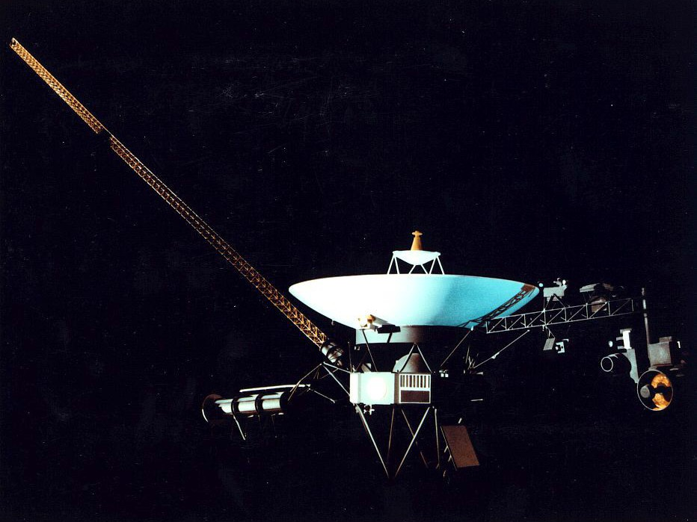

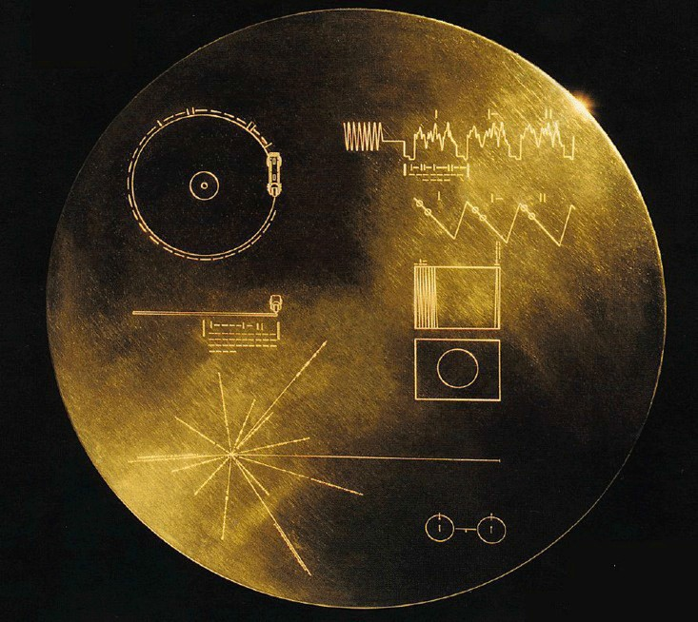

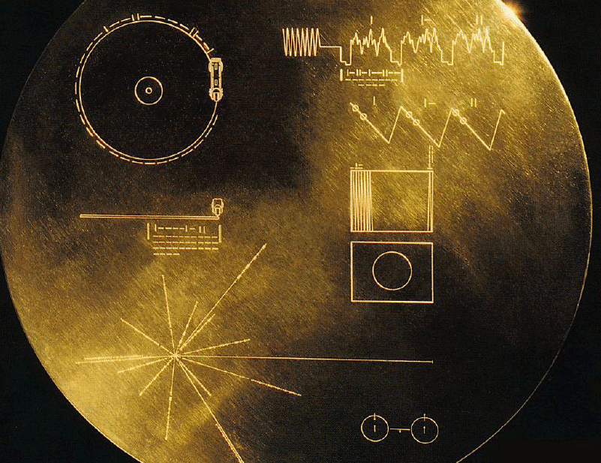

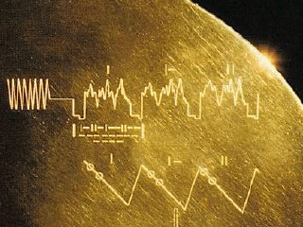

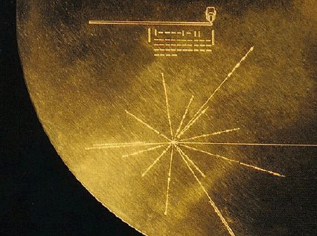

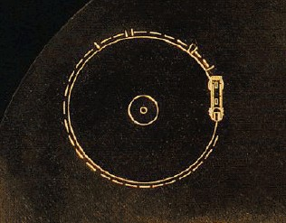

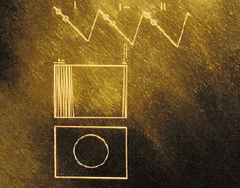

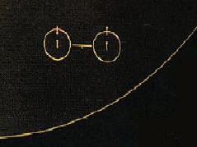

(What is the Golden Record?
“Pioneers 10 and 11, which preceded Voyager, both carried small metal plaques identifying their time and place of origin for the benefit of any other spacefarers that might find them in the distant future.

With this example before them, NASA placed a more ambitious message aboard Voyager 1 and 2 a kind of time capsule, intended to communicate a story of our world to extraterrestrials (YOU!).

The Voyager message is carried by a phonograph record-a 12-inch gold- plated copper disk containing sounds and images selected to portray the diversity of life and culture on Earth.” http://voyager.jpl.nasa.gov/spacecraft/goldenrec.html )

And you land here.

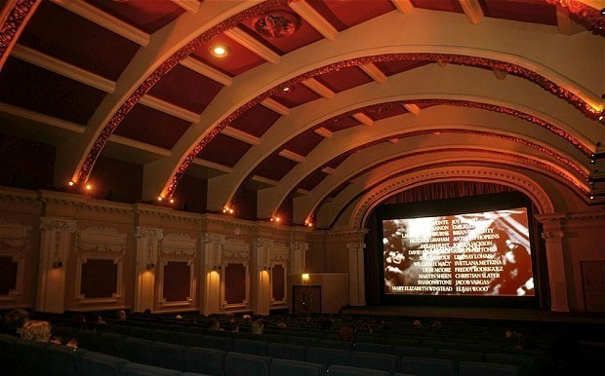

It feels a bit like home.

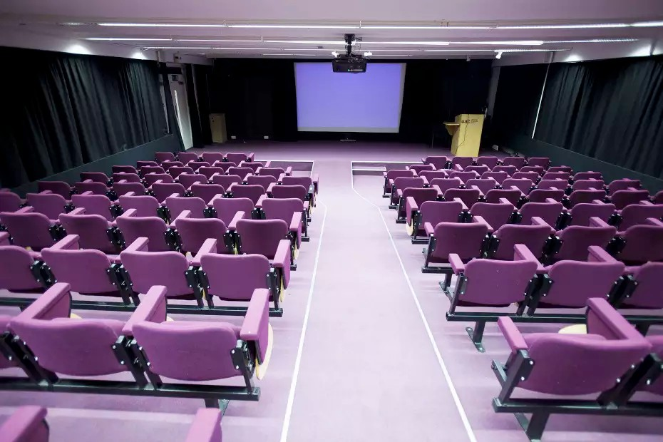

You blend in!

Nobody
Screams

Being a highly inquisitive species
you start some Exploratory Research

(Exploratory Research is undertaken when few or no previous studies exist. The aim is to look for patterns, hypotheses or ideas that can be tested and will form the basis for further research.)

Some words in a language
you do not understand appear on the glowing area in front of you.

Robots
Of Brixton

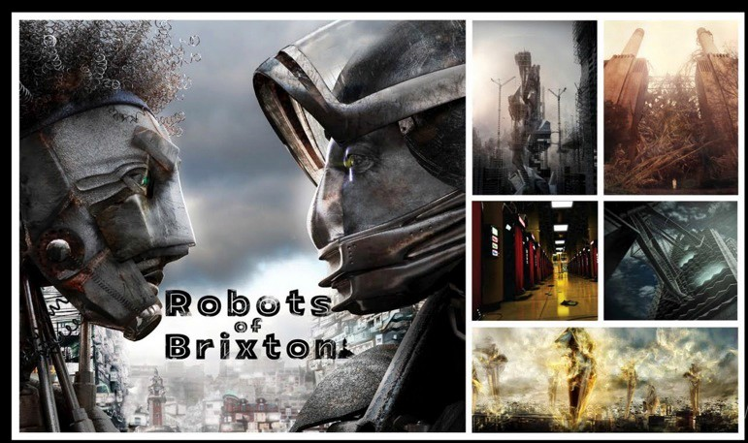

Activity

Free write about what you saw for 5 minutes

Reflection

Write down as much as you can about the
film you just saw. Describe it. Analyse it. Situate it.
Whatever first comes into your head. What did it may you feel/think about?

Do not censor your thoughts.

Write continuously for 5 minutes without stopping.
If you get stuck just write down the same
word over and over and over and over again.

Through some waves that you
find out are called

W.i.F.i.
you understand on Earth…

(Free Writing is the act of writing without
hesitating, and without self-censoring, accepting everything as it comes. This can help writers get started and sometimes unblock writers who are stuck. The process can yield ideas too as the writer gives up control to some extent. It has precedents in automatic writing, employed by the Surrealists, but that tended to have connotations of spiritual interventions, literally ‘ghost writing’.)

(You find out this is sometimes
called

‘Descriptive Research’
Descriptive research can be used to identify and classify the elements or characteristics of the subject.)

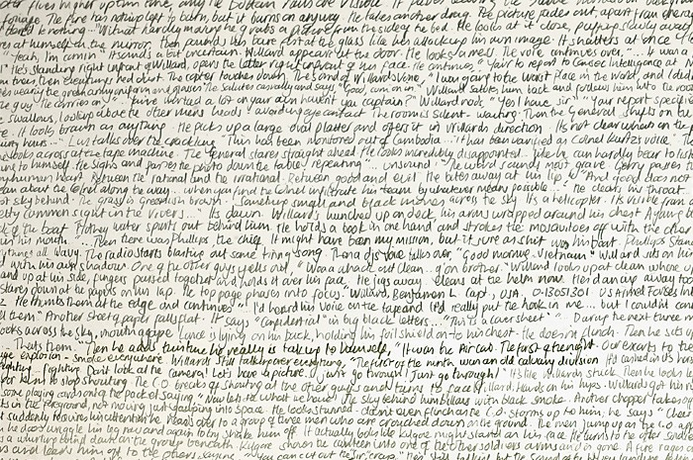

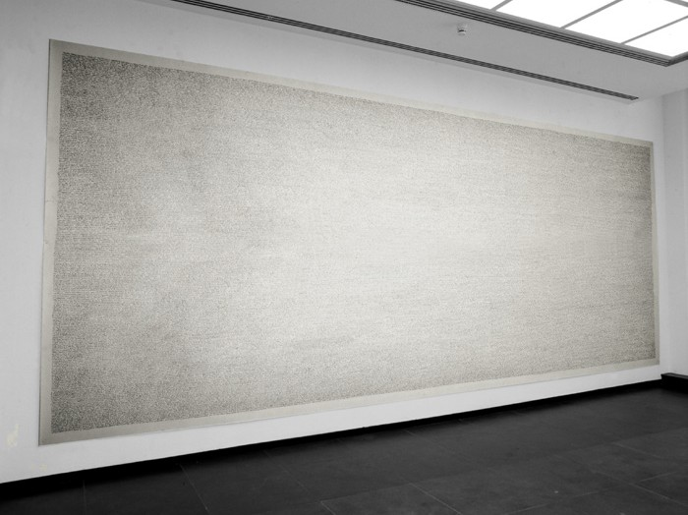

Apocalypse Now, 1997
by Fiona Banner,

(A Handwritten account of the film)

(To reflect upon what you are doing, or have done, you
need other methods to help you understand more fully the product or activity under scrutiny.)

(Leading M.I.T. social scientist and consultant, Donald
Schön in his book:

The Reflective Practitioner: How Professionals Think in Action (1991)

distinguishes between reflection-on-action and
reflection-in-action in the following way: paraphrased)

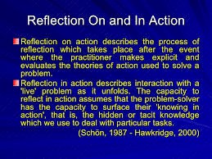

You are
curious.

Very curious.

You want to know more about the film you have just seen.

You are a bit confused and cannot remember exactly what happened.

Through THE WIFI you come across a way of possibly looking at this film more closely.

It is called

Shot by Shot Analysis
http://filmtheory.wikispaces.com/Shot+By+Shot+Analysis+Guide

You think it might help you remember the film?.

You think it might help you analyse the film?.

Luckily for you one of your
external memory devices has slowly recorded some of the images
from the film.

You try and remember what
was the first image you saw
in the film.

What was it?



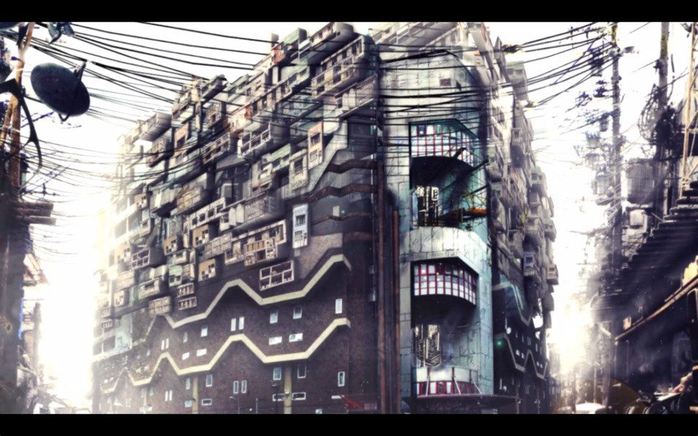

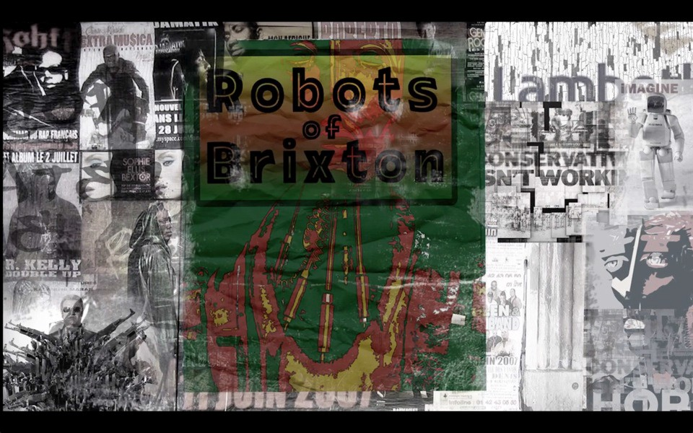

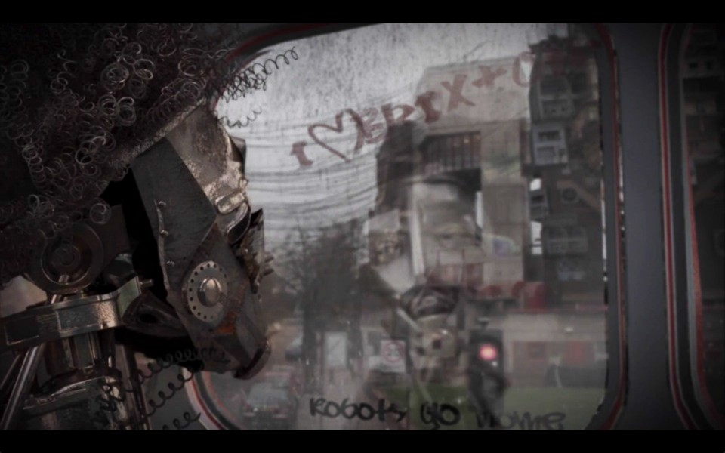

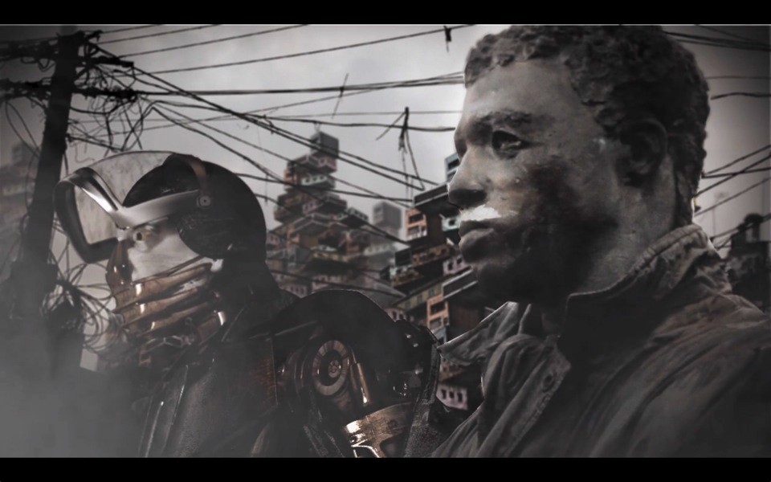

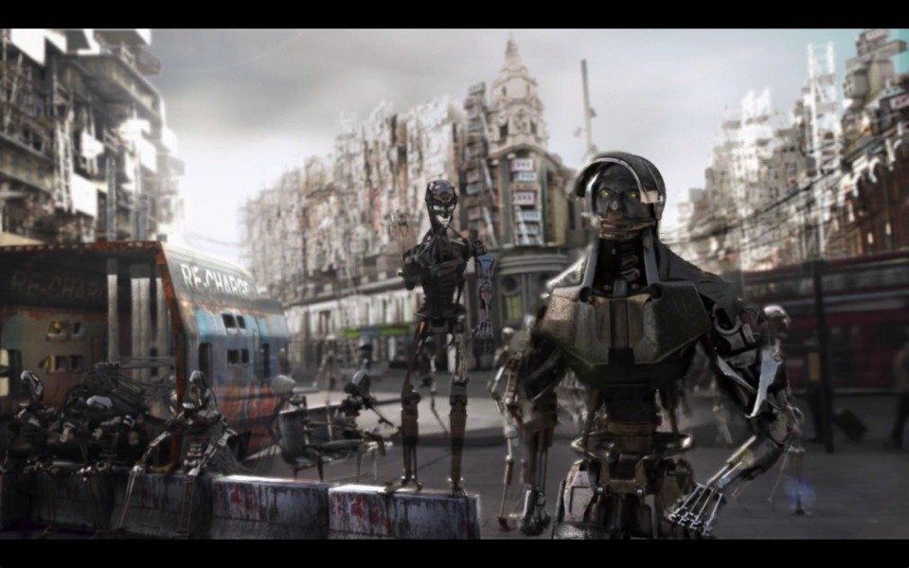

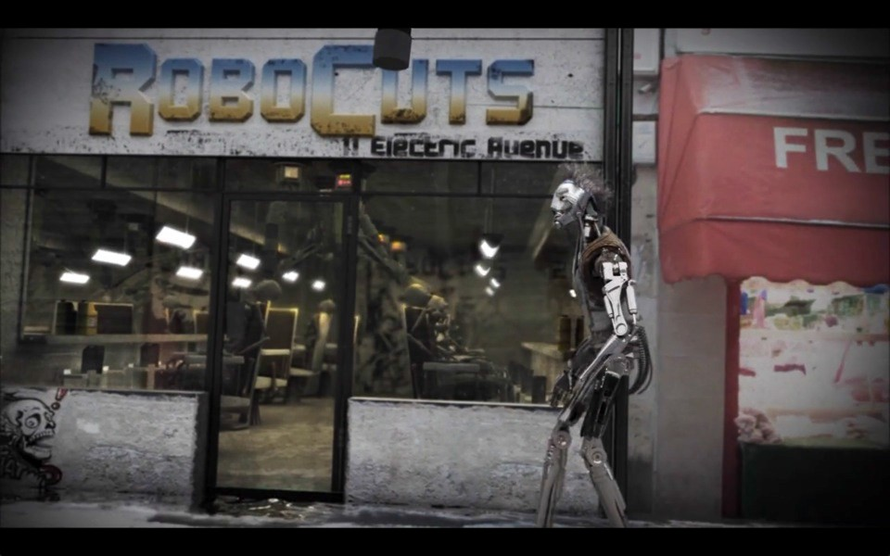

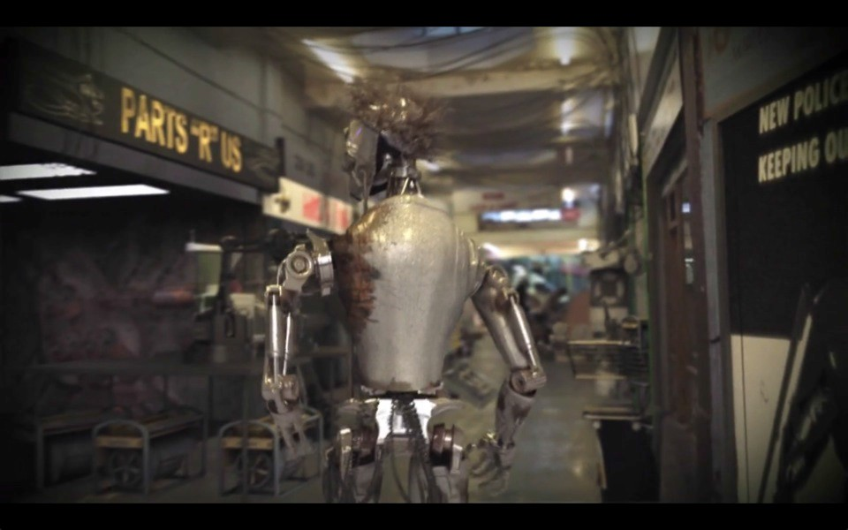

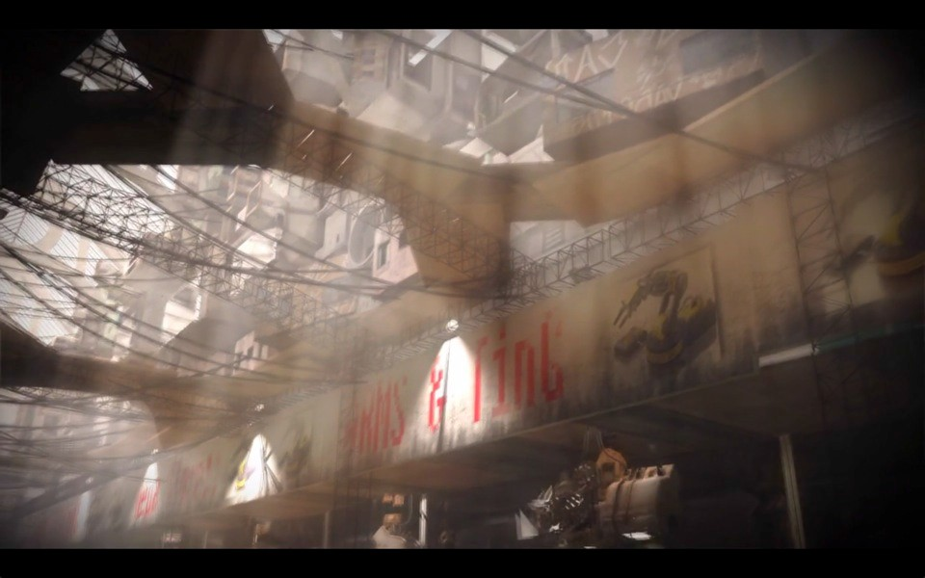

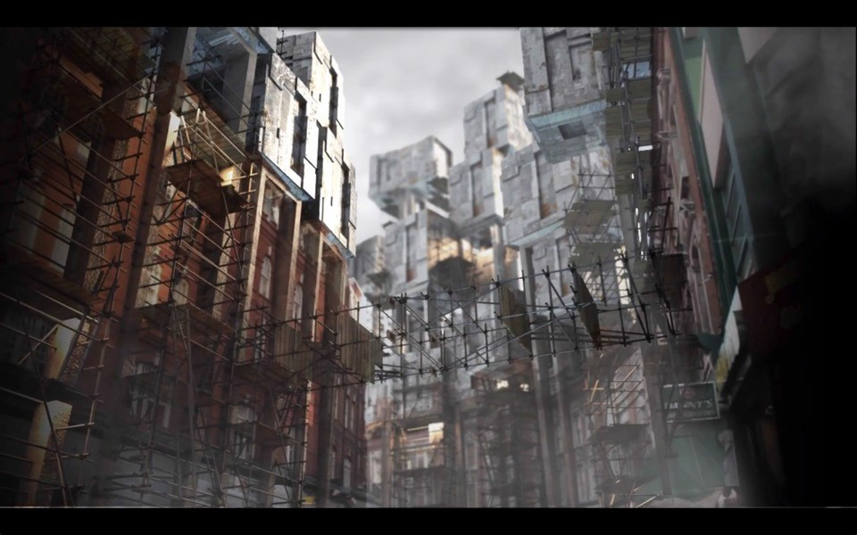

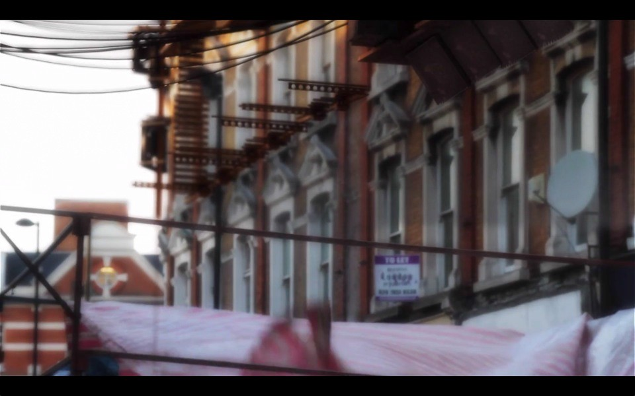



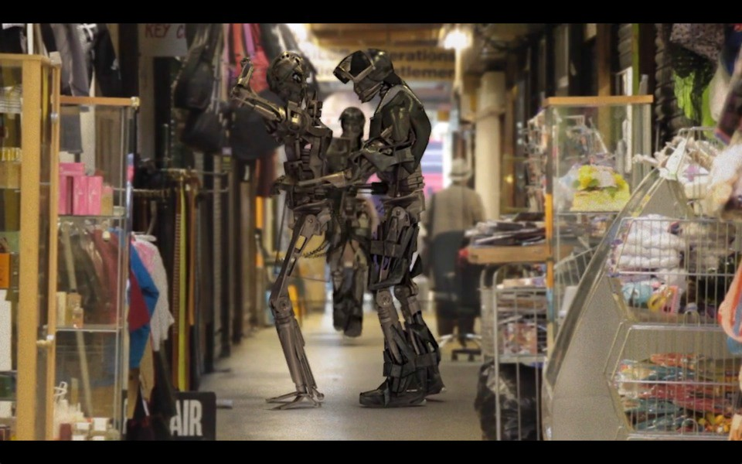

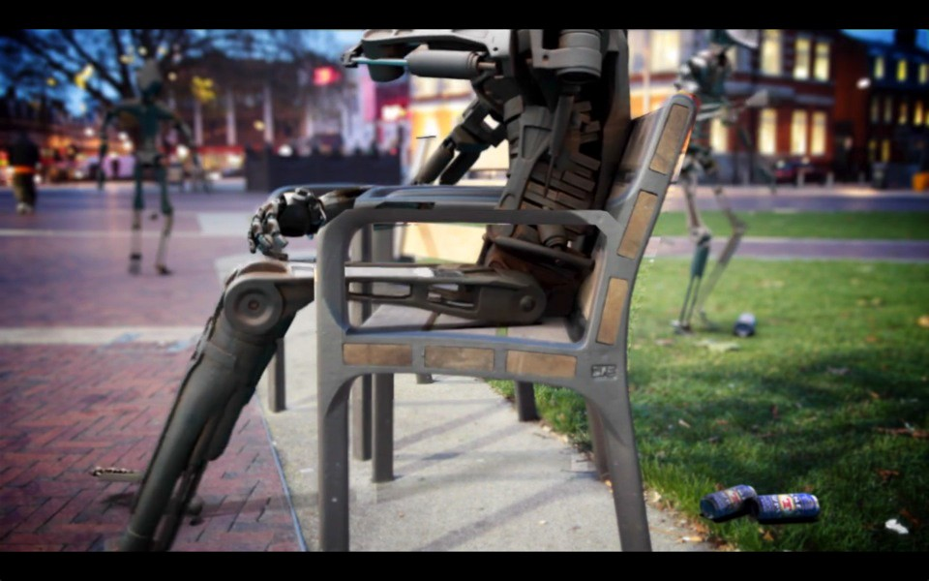

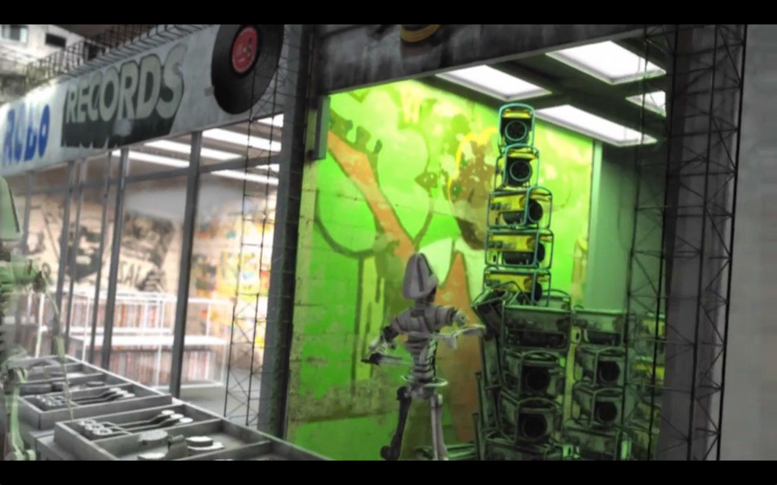

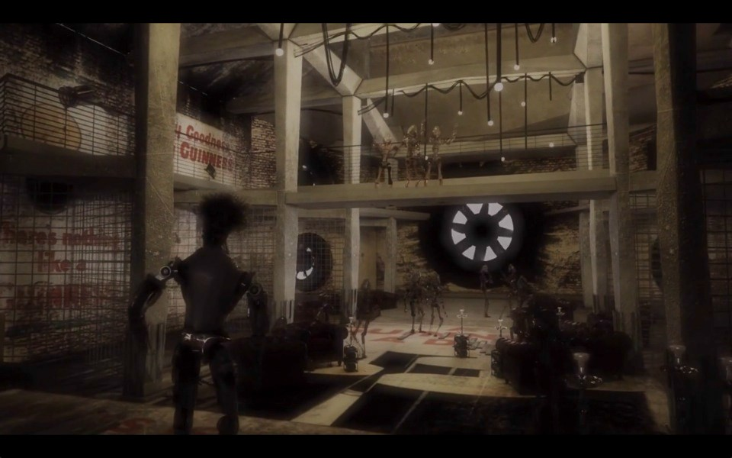



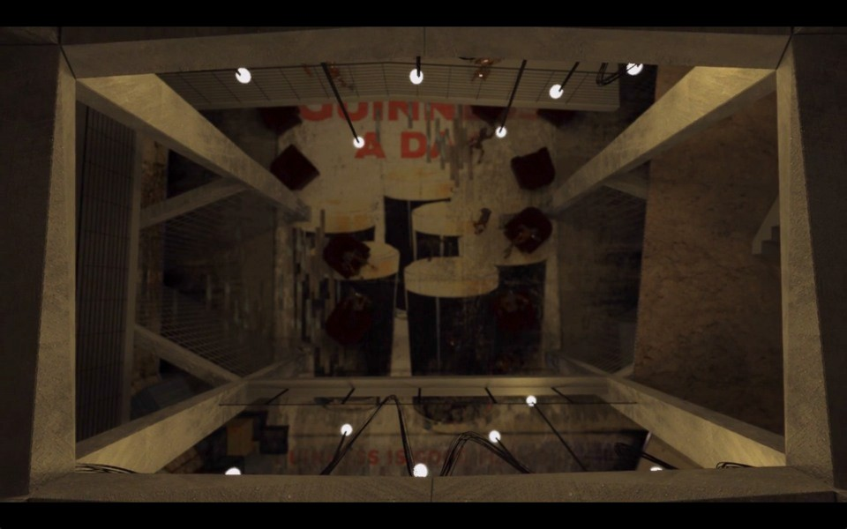

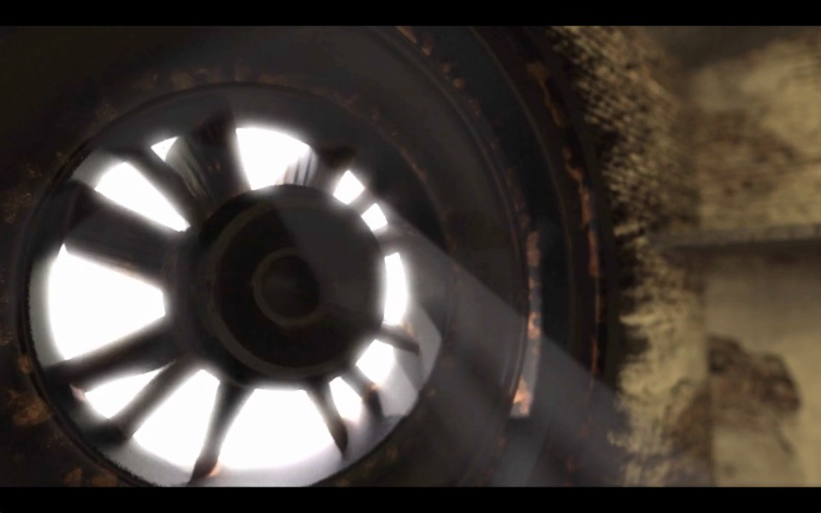

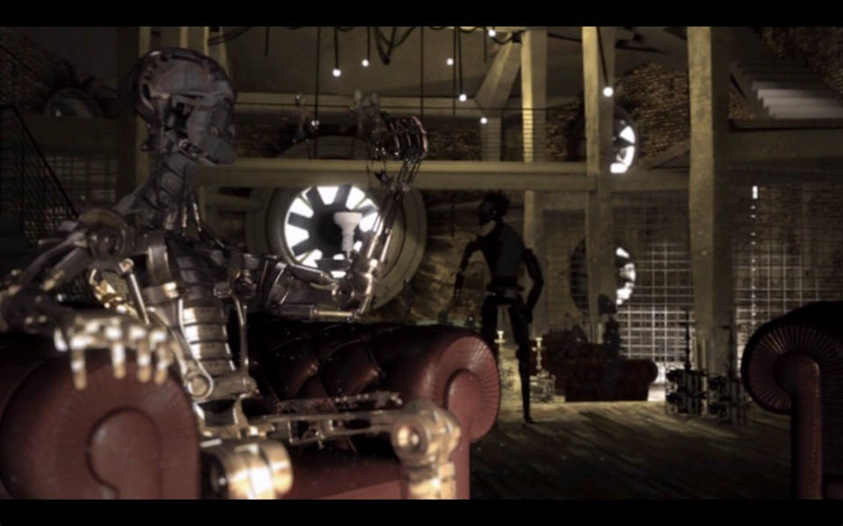

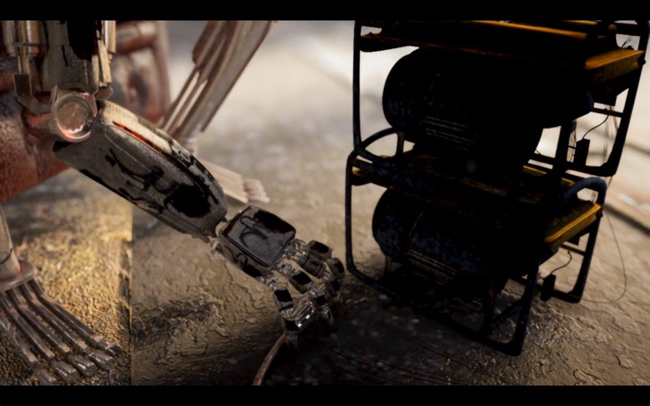



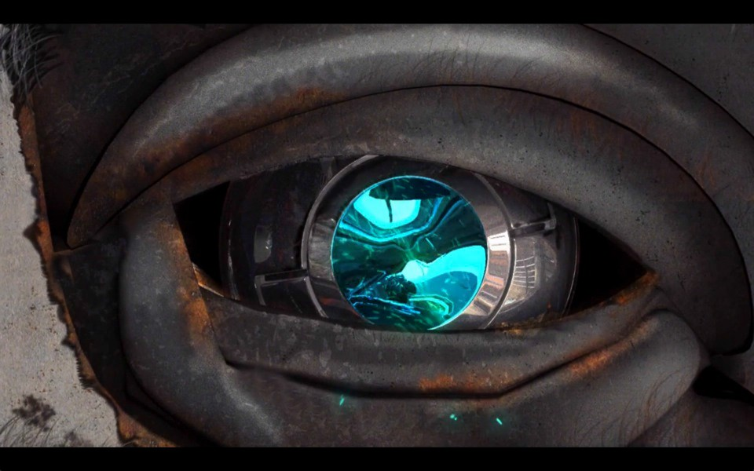

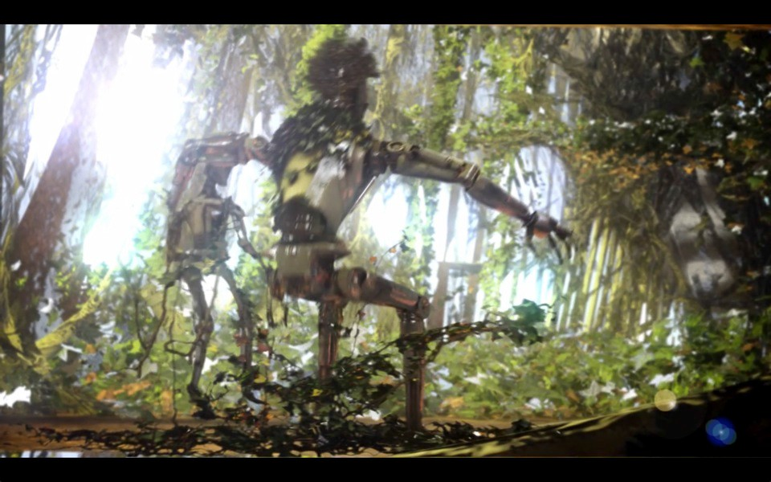

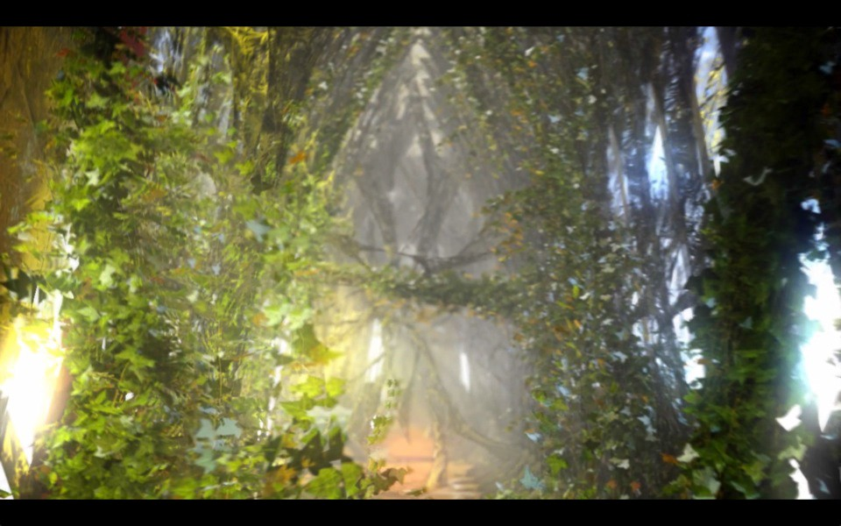

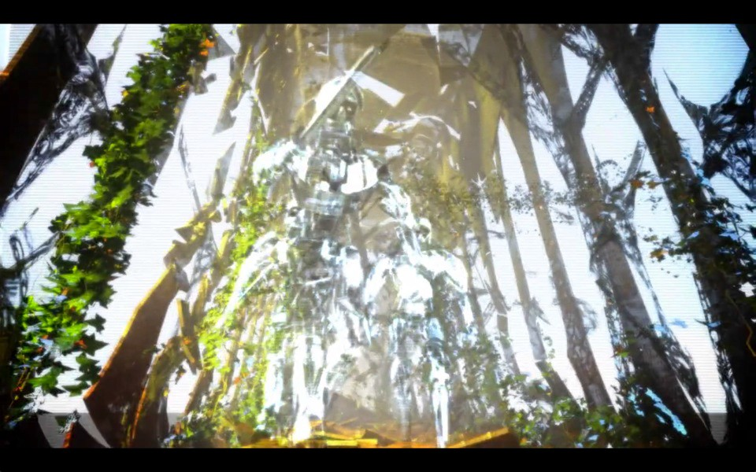

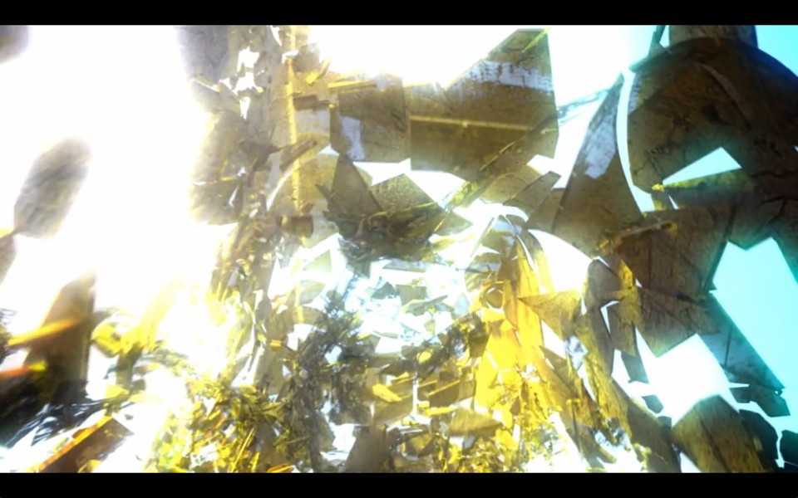

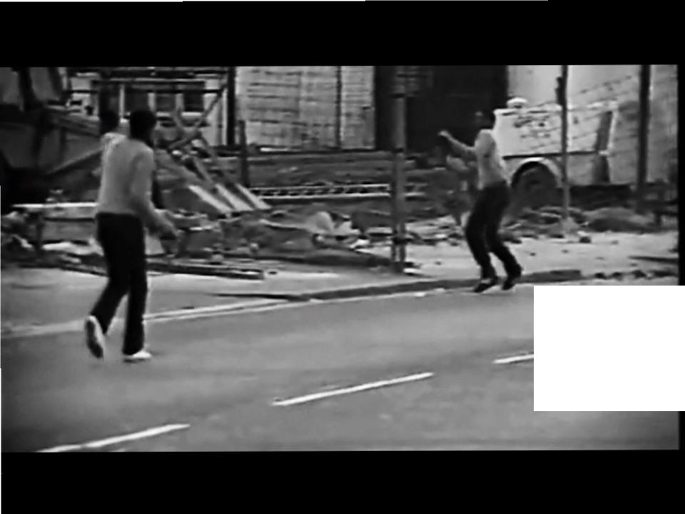

-

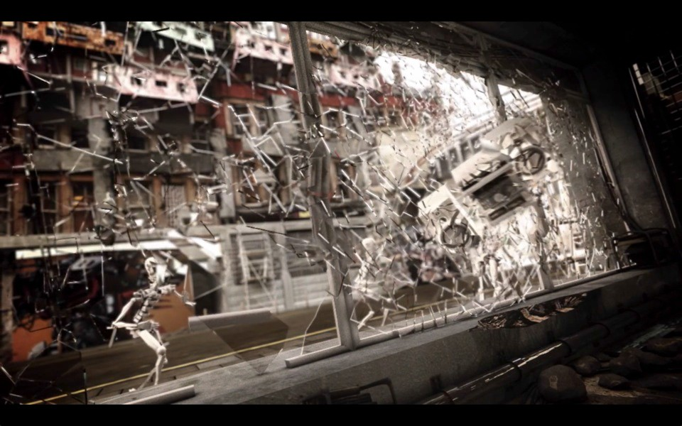

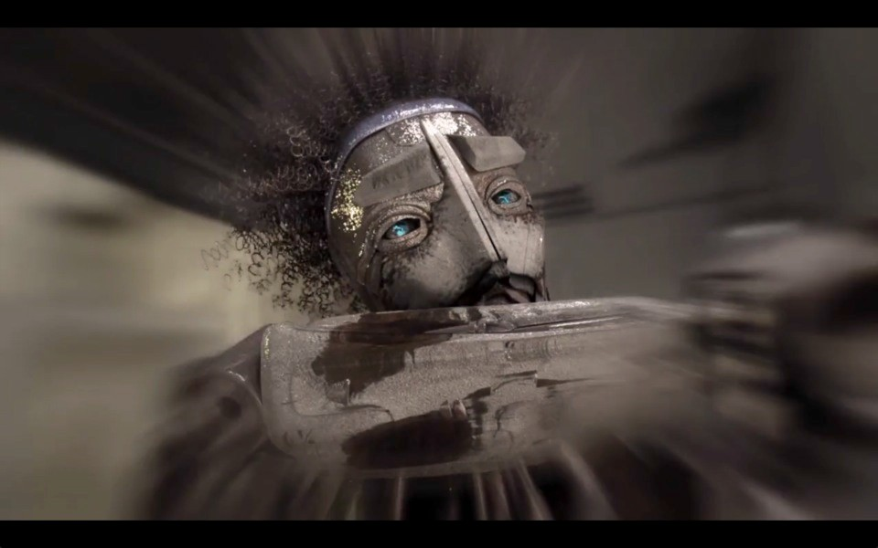

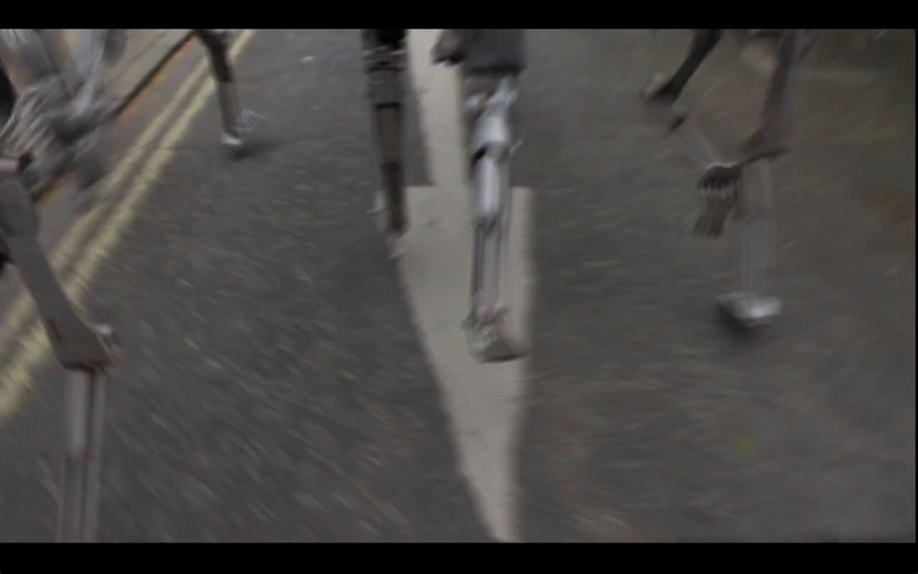

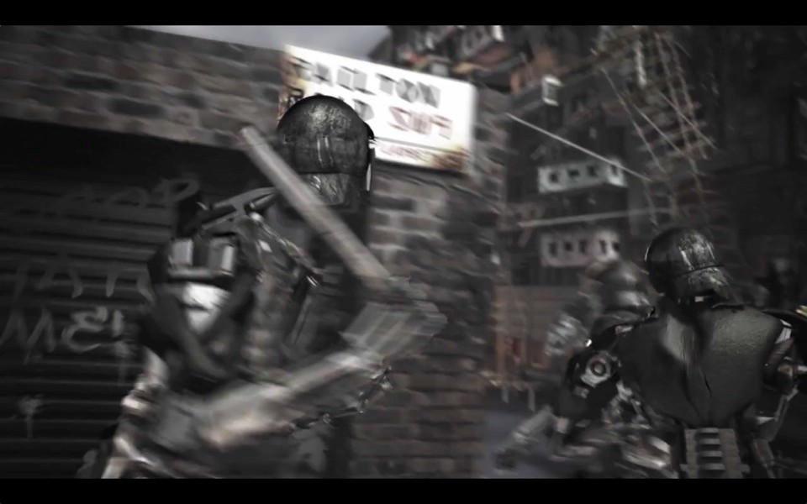

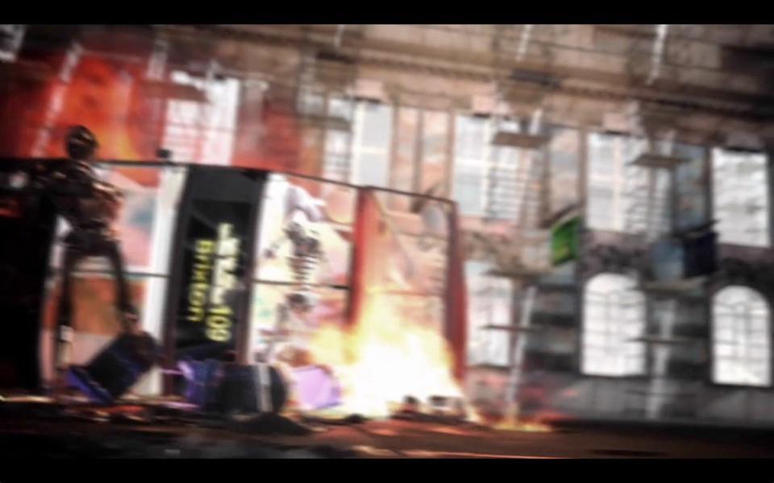

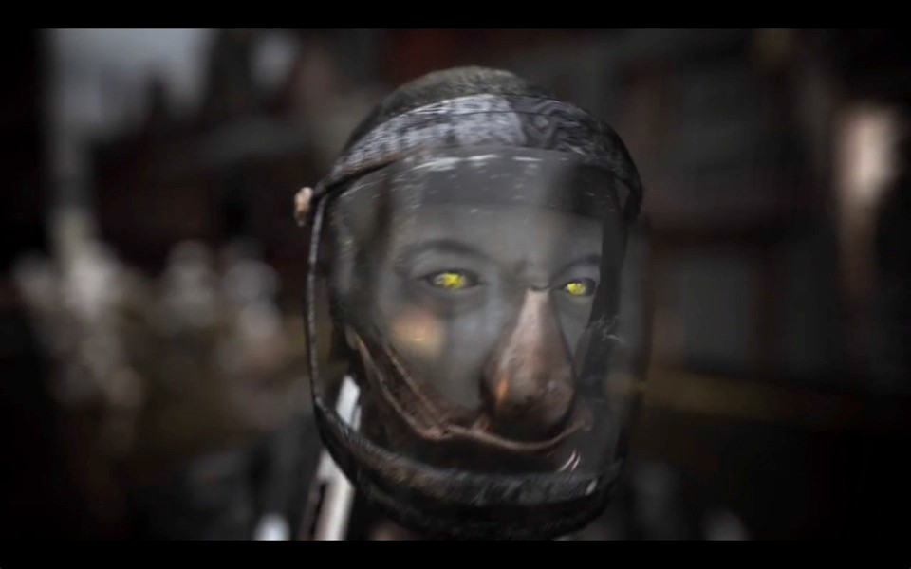



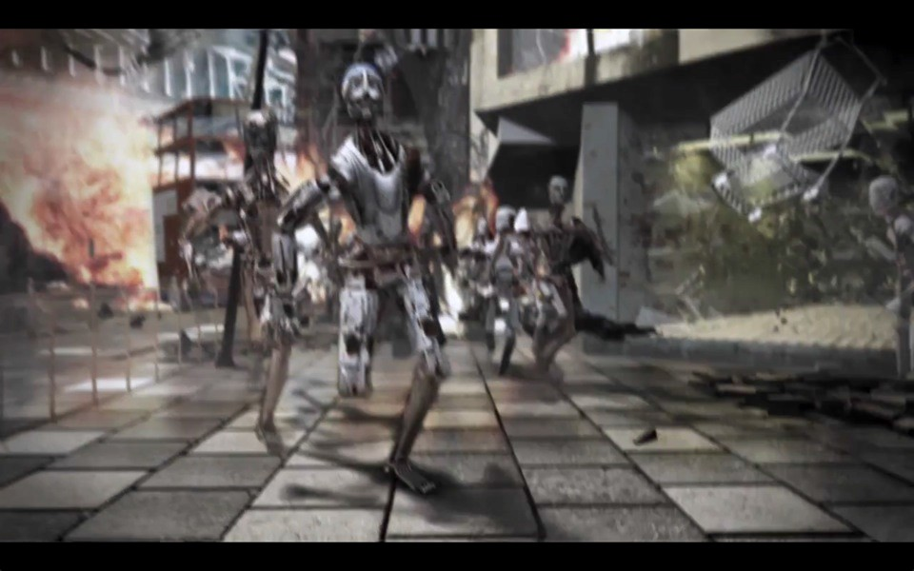

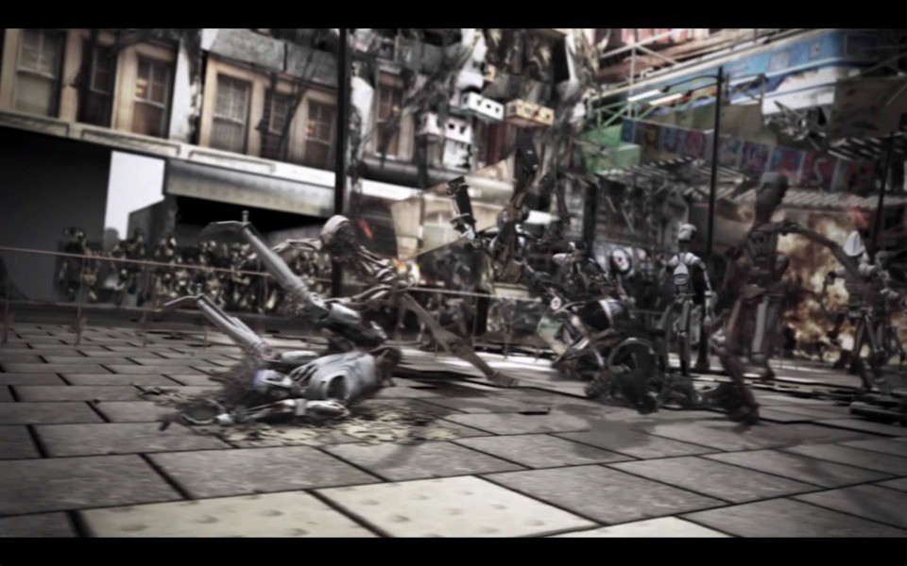

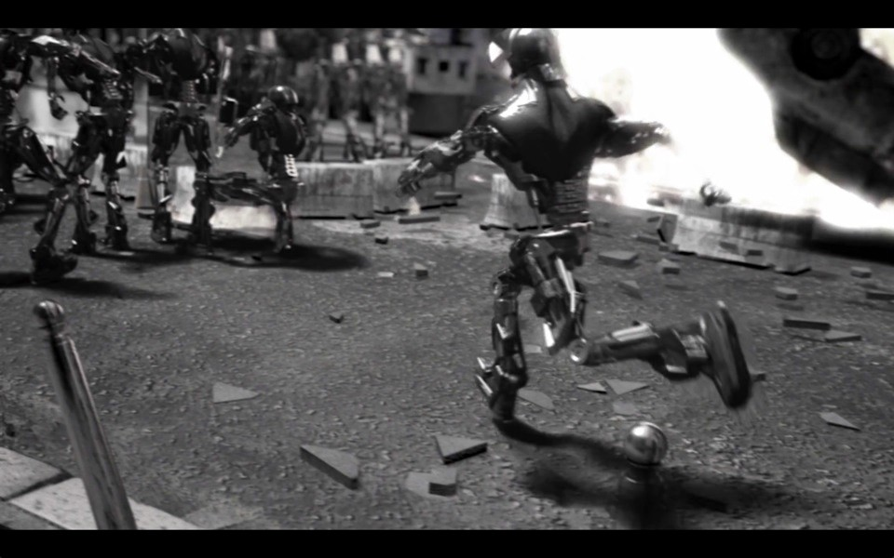

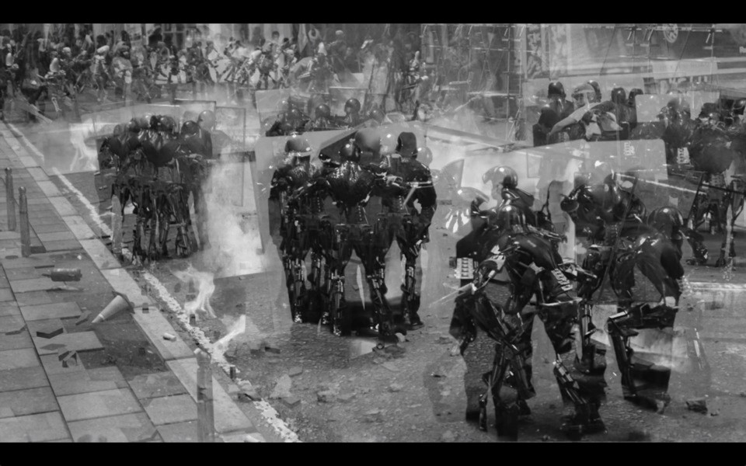

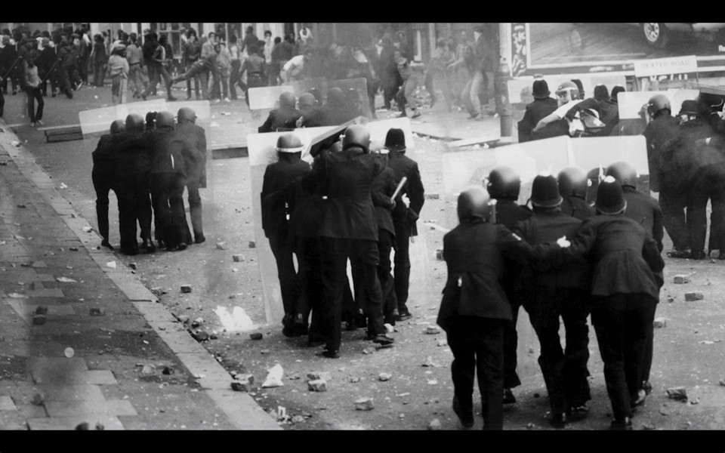

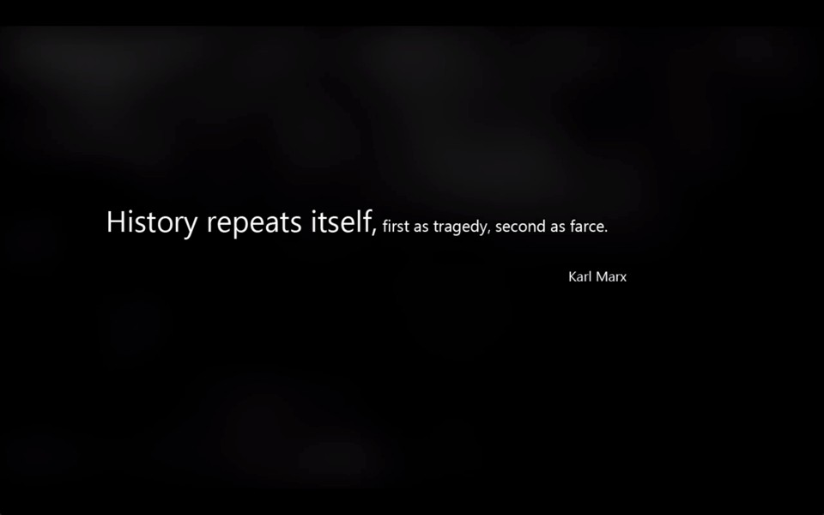

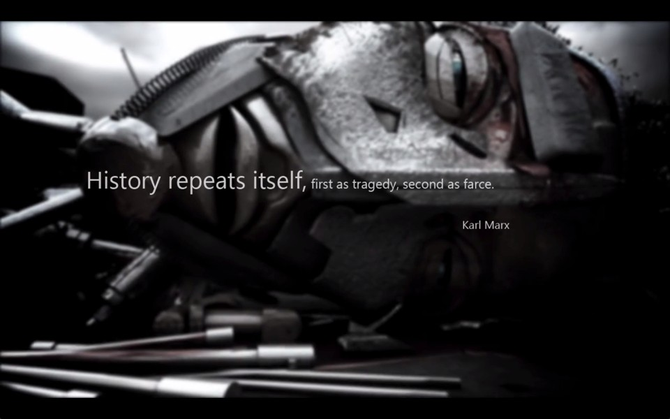

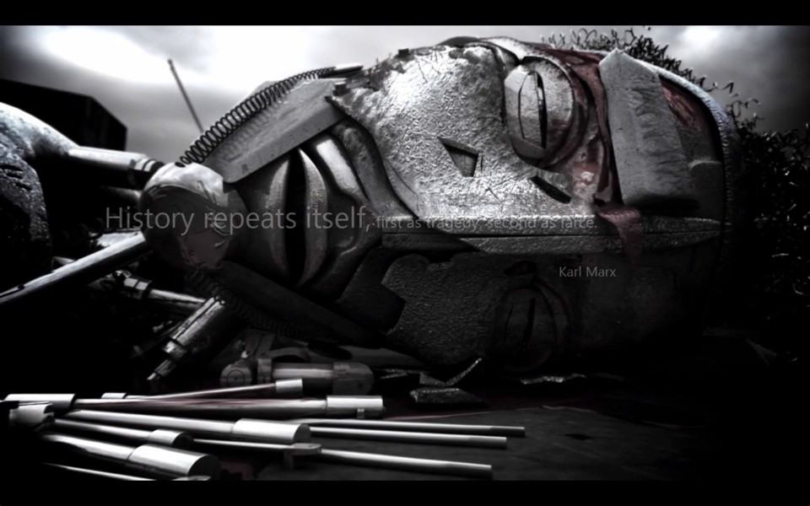

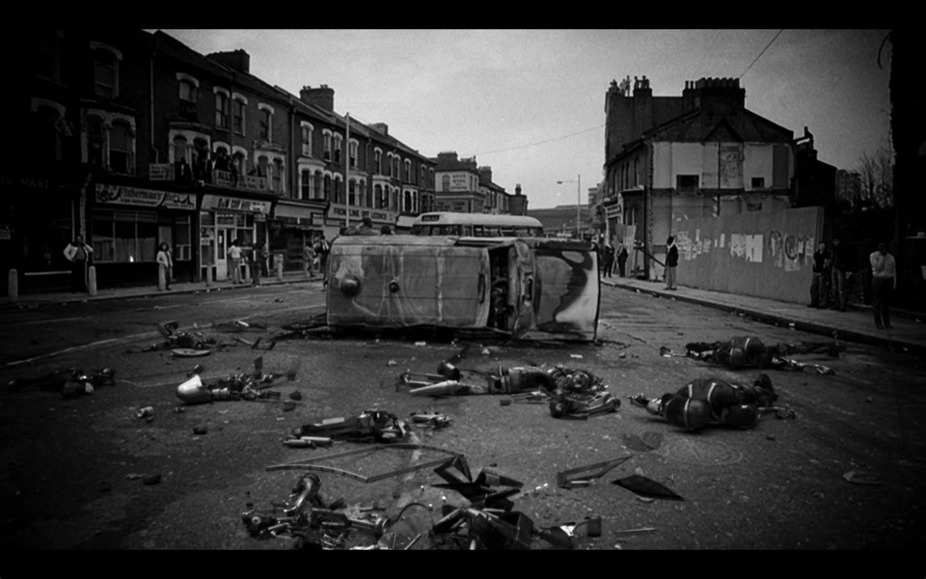

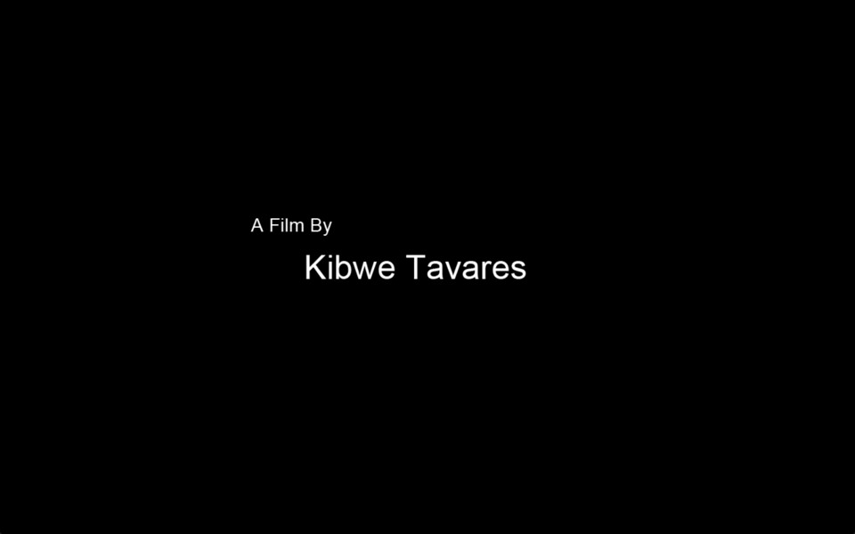

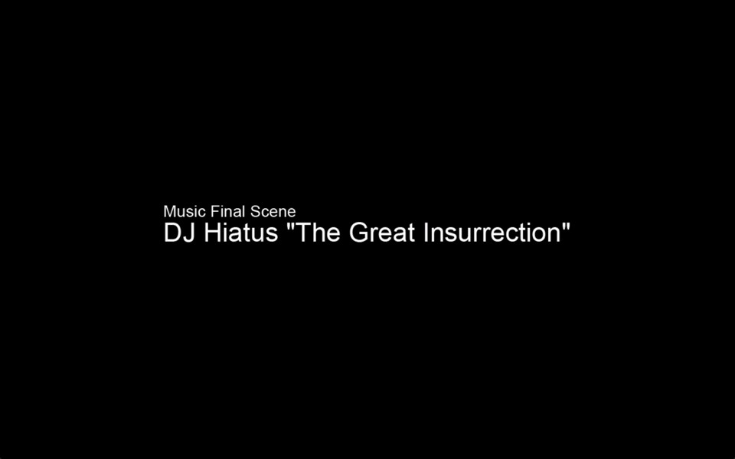

You may have gained some more information from looking back at the images you have recorded.

BUT

not enough to satisfy your insatiable…



The film is over,
but there seems to be many sources of information around you.

They seem intelligent!

(Discuss the film with the people around
you for 5 minutes. Then think about how you could situate this film in diﬀerent contexts from which you could then analyse it more specifically?

Write down a list of these contexts and then choose a member of your group to speak for you.)

Introduc

tion to

D.A.S.

Describe Analyse Situate

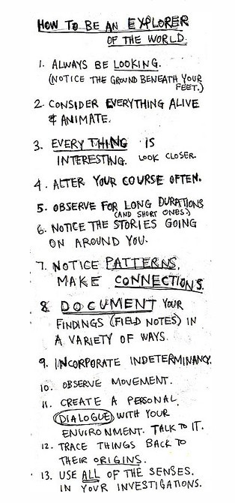



How many ways can you analyse a film? Or any other work of Cultural Production

Some methods of analysis?
Historical, Sociological, Psychological, Political,
Marxism, Frankfurt School, Critical Theory, Capitalism, Commodification, Psychoanalysis, Feminism, Gender studies,
Postcolonial Criticism
Semiotics, Aesthetics, Visual Rhetoric/Visual Literacy Technological, Apparatus theory Ethnographic, Anthropological
Literary theory, Linguistics, Discourse Analysis. Narratology, Hermeneutics
Philosophical, Ethics, Aﬀect/Eﬀect
Formalist film theory, Genre studies, Iconic analysis, Auteur theory, Phenomenology,
Quantitative Research, Data Collection and Analysis, Positivism, Empirical, Observation,
Interviews, Post-modernism,
Structuralism, Post-structuralism,
Deconstructivism, Action Research, Exploratory Practice,

Some methods of analysis?
Historical, Sociological, Psychological, Political,
Marxism, Frankfurt School, Critical Theory, Capitalism, Commodification, Psychoanalysis, Feminism, Gender studies,
Postcolonial Criticism
Semiotics, Aesthetics, Visual Rhetoric/Visual Literacy Technological, Apparatus theory Ethnographic, Anthropological
Literary theory, Linguistics, Discourse Analysis. Narratology, Hermeneutics
Philosophical, Ethics, Aﬀect/Eﬀect
Formalist film theory, Genre studies, Iconic analysis, Auteur theory, Phenomenology,
Quantitative Research, Data Collection and Analysis, Positivism, Empirical, Observation,
Interviews, Post-modernism,
Structuralism, Post-structuralism,
Deconstructivism, Action Research, Exploratory Practice,

Some methods of analysis?
Historical, Sociological, Psychological, Political,
Marxism, Frankfurt School, Critical Theory, Capitalism, Commodification, Psychoanalysis, Feminism, Gender studies,
Postcolonial Criticism
Semiotics, Aesthetics, Visual Rhetoric/Visual Literacy Technological, Apparatus theory Ethnographic, Anthropological
Literary theory, Linguistics, Discourse Analysis. Narratology, Hermeneutics
Philosophical, Ethics, Aﬀect/Eﬀect
Formalist film theory, Genre studies, Iconic analysis, Auteur theory, Phenomenology,
Quantitative Research, Data Collection and Analysis, Positivism, Empirical, Observation,
Interviews, Post-modernism,
Structuralism, Post-structuralism,
Deconstructivism, Action Research, Exploratory Practice,

Some methods of analysis?
Historical, Sociological, Psychological, Political,
Marxism, Frankfurt School, Critical Theory, Capitalism, Commodification, Psychoanalysis, Feminism, Gender studies,
Postcolonial Criticism
Semiotics, Aesthetics, Visual Rhetoric/Visual Literacy Technological, Apparatus theory Ethnographic, Anthropological
Literary theory, Linguistics, Discourse Analysis. Narratology, Hermeneutics
Philosophical, Ethics, Aﬀect/Eﬀect
Formalist film theory, Genre studies, Iconic analysis, Auteur theory, Phenomenology,
Quantitative Research, Data Collection and Analysis, Positivism, Empirical, Observation,
Interviews, Post-modernism,
Structuralism, Post-structuralism,
Deconstructivism, Action Research, Exploratory Practice,

Some methods of analysis?
Historical, Sociological, Psychological, Political,
Marxism, Frankfurt School, Critical Theory, Capitalism, Commodification, Psychoanalysis, Feminism, Gender studies,
Postcolonial Criticism
Semiotics, Aesthetics, Visual Rhetoric/Visual Literacy Technological, Apparatus theory Ethnographic, Anthropological
Literary theory, Linguistics, Discourse Analysis. Narratology, Hermeneutics
Philosophical, Ethics, Aﬀect/Eﬀect
Formalist film theory, Genre studies, Iconic analysis, Auteur theory, Phenomenology,
Quantitative Research, Data Collection and Analysis, Positivism, Empirical, Observation,
Interviews, Post-modernism,
Structuralism, Post-structuralism,
Deconstructivism, Action Research, Exploratory Practice,

Some methods of analysis?
Historical, Sociological, Psychological, Political,
Marxism, Frankfurt School, Critical Theory, Capitalism, Commodification, Psychoanalysis, Feminism, Gender studies,
Postcolonial Criticism
Semiotics, Aesthetics, Visual Rhetoric/Visual Literacy Technological, Apparatus theory Ethnographic, Anthropological
Literary theory, Linguistics, Discourse Analysis. Narratology, Hermeneutics
Philosophical, Ethics, Aﬀect/Eﬀect
Formalist film theory, Genre studies, Iconic analysis, Auteur theory, Phenomenology,
Quantitative Research, Data Collection and Analysis, Positivism, Empirical, Observation,
Interviews, Post-modernism,
Structuralism, Post-structuralism,
Deconstructivism, Action Research, Exploratory Practice,

Some methods of analysis?
Historical, Sociological, Psychological, Political,
Marxism, Frankfurt School, Critical Theory, Capitalism, Commodification, Psychoanalysis, Feminism, Gender studies,
Postcolonial Criticism
Semiotics, Aesthetics, Visual Rhetoric/Visual Literacy Technological, Apparatus theory Ethnographic, Anthropological
Literary theory, Linguistics, Discourse Analysis. Narratology, Hermeneutics
Philosophical, Ethics, Aﬀect/Eﬀect
Formalist film theory, Genre studies, Iconic analysis, Auteur theory, Phenomenology,
Quantitative Research, Data Collection and Analysis, Positivism, Empirical, Observation,
Interviews, Post-modernism,
Structuralism, Post-structuralism,
Deconstructivism, Action Research, Exploratory Practice,

Some methods of analysis?
Historical, Sociological, Psychological, Political,
Marxism, Frankfurt School, Critical Theory, Capitalism, Commodification, Psychoanalysis, Feminism, Gender studies,
Postcolonial Criticism
Semiotics, Aesthetics, Visual Rhetoric/Visual Literacy Technological, Apparatus theory Ethnographic, Anthropological
Literary theory, Linguistics, Discourse Analysis. Narratology, Hermeneutics
Philosophical, Ethics, Aﬀect/Eﬀect
Formalist film theory, Genre studies, Iconic analysis, Auteur theory, Phenomenology,
Quantitative Research, Data Collection and Analysis, Positivism, Empirical, Observation,
Interviews, Post-modernism,
Structuralism, Post-structuralism,
Deconstructivism, Action Research, Exploratory Practice,

Some methods of analysis?
Historical, Sociological, Psychological, Political,
Marxism, Frankfurt School, Critical Theory, Capitalism, Commodification, Psychoanalysis, Feminism, Gender studies,
Postcolonial Criticism
Semiotics, Aesthetics, Visual Rhetoric/Visual Literacy Technological, Apparatus theory Ethnographic, Anthropological
Literary theory, Linguistics, Discourse Analysis. Narratology, Hermeneutics
Philosophical, Ethics, Aﬀect/Eﬀect
Formalist film theory, Genre studies, Iconic analysis, Auteur theory, Phenomenology,
Quantitative Research, Data Collection and Analysis, Positivism, Empirical, Observation,
Interviews, Post-modernism,
Structuralism, Post-structuralism,
Deconstructivism, Action Research, Exploratory Practice,

Some methods of analysis?
Historical, Sociological, Psychological, Political,
Marxism, Frankfurt School, Critical Theory, Capitalism, Commodification, Psychoanalysis, Feminism, Gender studies,
Postcolonial Criticism
Semiotics, Aesthetics, Visual Rhetoric/Visual Literacy Technological, Apparatus theory Ethnographic, Anthropological
Literary theory, Linguistics, Discourse Analysis. Narratology, Hermeneutics
Philosophical, Ethics, Aﬀect/Eﬀect
Formalist film theory, Genre studies, Iconic analysis, Auteur theory, Phenomenology,
Quantitative Research, Data Collection and Analysis, Positivism, Empirical, Observation,
Interviews, Post-modernism,
Structuralism, Post-structuralism,
Deconstructivism, Action Research, Exploratory Practice,

Some methods of analysis?
Historical, Sociological, Psychological, Political,
Marxism, Frankfurt School, Critical Theory, Capitalism, Commodification, Psychoanalysis, Feminism, Gender studies,
Postcolonial Criticism
Semiotics, Aesthetics, Visual Rhetoric/Visual Literacy Technological, Apparatus theory Ethnographic, Anthropological
Literary theory, Linguistics, Discourse Analysis. Narratology, Hermeneutics
Philosophical, Ethics, Aﬀect/Eﬀect
Formalist film theory, Genre studies, Iconic analysis, Auteur theory, Phenomenology,
Quantitative Research, Data Collection and Analysis, Positivism, Empirical, Observation,
Interviews, Post-modernism,
Structuralism, Post-structuralism,
Deconstructivism, Action Research, Exploratory Practice,

Some methods of analysis?
Historical, Sociological, Psychological, Political,
Marxism, Frankfurt School, Critical Theory, Capitalism, Commodification, Psychoanalysis, Feminism, Gender studies,
Postcolonial Criticism
Semiotics, Aesthetics, Visual Rhetoric/Visual Literacy Technological, Apparatus theory Ethnographic, Anthropological
Literary theory, Linguistics, Discourse Analysis. Narratology, Hermeneutics
Philosophical, Ethics, Aﬀect/Eﬀect
Formalist film theory, Genre studies, Iconic analysis, Auteur theory, Phenomenology,
Quantitative Research, Data Collection and Analysis, Positivism, Empirical, Observation,
Interviews, Post-modernism,
Structuralism, Post-structuralism,
Deconstructivism, Action Research, Exploratory Practice,

Some methods of analysis?
Historical, Sociological, Psychological, Political,
Marxism, Frankfurt School, Critical Theory, Capitalism, Commodification, Psychoanalysis, Feminism, Gender studies,
Postcolonial Criticism
Semiotics, Aesthetics, Visual Rhetoric/Visual Literacy Technological, Apparatus theory Ethnographic, Anthropological
Literary theory, Linguistics, Discourse Analysis. Narratology, Hermeneutics
Philosophical, Ethics, Aﬀect/Eﬀect
Formalist film theory, Genre studies, Iconic analysis, Auteur theory, Phenomenology,
Quantitative Research, Data Collection and Analysis, Positivism, Empirical, Observation,
Interviews, Post-modernism,
Structuralism, Post-structuralism,
Deconstructivism, Action Research, Exploratory Practice,

Some methods of analysis?
Historical, Sociological, Psychological, Political,
Marxism, Frankfurt School, Critical Theory, Capitalism, Commodification, Psychoanalysis, Feminism, Gender studies,
Postcolonial Criticism
Semiotics, Aesthetics, Visual Rhetoric/Visual Literacy Technological, Apparatus theory Ethnographic, Anthropological
Literary theory, Linguistics, Discourse Analysis. Narratology, Hermeneutics
Philosophical, Ethics, Aﬀect/Eﬀect
Formalist film theory, Genre studies, Iconic analysis, Auteur theory, Phenomenology,
Quantitative Research, Data Collection and Analysis, Positivism, Empirical, Observation,
Interviews, Post-modernism,
Structuralism, Post-structuralism,
Deconstructivism, Action Research, Exploratory Practice,

Some methods of analysis?
Historical, Sociological, Psychological, Political,
Marxism, Frankfurt School, Critical Theory, Capitalism, Commodification, Psychoanalysis, Feminism, Gender studies,
Postcolonial Criticism
Semiotics, Aesthetics, Visual Rhetoric/Visual Literacy Technological, Apparatus theory Ethnographic, Anthropological
Literary theory, Linguistics, Discourse Analysis. Narratology, Hermeneutics
Philosophical, Ethics, Aﬀect/Eﬀect
Formalist film theory, Genre studies, Iconic analysis, Auteur theory, Phenomenology,
Quantitative Research, Data Collection and Analysis, Positivism, Empirical, Observation,
Interviews, Post-modernism,
Structuralism, Post-structuralism,
Deconstructivism, Action Research, Exploratory Practice,

Some methods of analysis?
Historical, Sociological, Psychological, Political,
Marxism, Frankfurt School, Critical Theory, Capitalism, Commodification, Psychoanalysis, Feminism, Gender studies,
Postcolonial Criticism
Semiotics, Aesthetics, Visual Rhetoric/Visual Literacy Technological, Apparatus theory Ethnographic, Anthropological
Literary theory, Linguistics, Discourse Analysis. Narratology, Hermeneutics
Philosophical, Ethics, Aﬀect/Eﬀect
Formalist film theory, Genre studies, Iconic analysis, Auteur theory, Phenomenology,
Quantitative Research, Data Collection and Analysis, Positivism, Empirical, Observation,
Interviews, Post-modernism,
Structuralism, Post-structuralism,
Deconstructivism, Action Research, Exploratory Practice,

Some methods of analysis?
Historical, Sociological, Psychological, Political,
Marxism, Frankfurt School, Critical Theory, Capitalism, Commodification, Psychoanalysis, Feminism, Gender studies,
Postcolonial Criticism
Semiotics, Aesthetics, Visual Rhetoric/Visual Literacy Technological, Apparatus theory Ethnographic, Anthropological
Literary theory, Linguistics, Discourse Analysis. Narratology, Hermeneutics
Philosophical, Ethics, Aﬀect/Eﬀect
Formalist film theory, Genre studies, Iconic analysis, Auteur theory, Phenomenology,
Quantitative Research, Data Collection and Analysis, Positivism, Empirical, Observation,
Interviews, Post-modernism,
Structuralism, Post-structuralism,
Deconstructivism, Action Research, Exploratory Practice,

Some methods of analysis?
Historical, Sociological, Psychological, Political,
Marxism, Frankfurt School, Critical Theory, Capitalism, Commodification, Psychoanalysis, Feminism, Gender studies,
Postcolonial Criticism
Semiotics, Aesthetics, Visual Rhetoric/Visual Literacy Technological, Apparatus theory Ethnographic, Anthropological
Literary theory, Linguistics, Discourse Analysis. Narratology, Hermeneutics
Philosophical, Ethics, Aﬀect/Eﬀect
Formalist film theory, Genre studies, Iconic analysis, Auteur theory, Phenomenology,
Quantitative Research, Data Collection and Analysis, Positivism, Empirical, Observation,
Interviews, Post-modernism,
Structuralism, Post-structuralism,
Deconstructivism, Action Research, Exploratory Practice,

Some methods of analysis?
Historical, Sociological, Psychological, Political,
Marxism, Frankfurt School, Critical Theory, Capitalism, Commodification, Psychoanalysis, Feminism, Gender studies,
Postcolonial Criticism
Semiotics, Aesthetics, Visual Rhetoric/Visual Literacy Technological, Apparatus theory Ethnographic, Anthropological
Literary theory, Linguistics, Discourse Analysis. Narratology, Hermeneutics
Philosophical, Ethics, Aﬀect/Eﬀect
Formalist film theory, Genre studies, Iconic analysis, Auteur theory, Phenomenology,
Quantitative Research, Data Collection and Analysis, Positivism, Empirical, Observation,
Interviews, Post-modernism,
Structuralism, Post-structuralism,
Deconstructivism, Action Research, Exploratory Practice,

Some methods of analysis?
Historical, Sociological, Psychological, Political,
Marxism, Frankfurt School, Critical Theory, Capitalism, Commodification, Psychoanalysis, Feminism, Gender studies,
Postcolonial Criticism
Semiotics, Aesthetics, Visual Rhetoric/Visual Literacy Technological, Apparatus theory Ethnographic, Anthropological,
Literary theory, Linguistics, Discourse Analysis. Narratology, Hermeneutics
Philosophical, Ethics, Aﬀect/Eﬀect
Formalist film theory, Genre studies, Iconic analysis, Auteur theory, Phenomenology,
Quantitative Research, Data Collection and Analysis, Positivism, Empirical, Observation,
Interviews, Post-modernism,
Structuralism, Post-structuralism,
Deconstructivism, Action Research, Exploratory Practice,

Some methods of analysis?
Historical, Sociological, Psychological, Political,
Marxism, Frankfurt School, Critical Theory, Capitalism, Commodification, Psychoanalysis, Feminism, Gender studies,
Postcolonial Criticism
Semiotics, Aesthetics, Visual Rhetoric/Visual Literacy Technological, Apparatus theory Ethnographic, Anthropological,
Literary theory, Linguistics, Discourse Analysis. Narratology, Hermeneutics
Philosophical, Ethics, Aﬀect/Eﬀect
Formalist film theory, Genre studies, Iconic analysis, Auteur theory, Phenomenology,
Quantitative Research, Data Collection and Analysis, Positivism, Empirical, Observation,
Interviews, Post-modernism,
Structuralism, Post-structuralism,
Deconstructivism, Action Research, Exploratory Practice,

Some methods of analysis?
Historical, Sociological, Psychological, Political,
Marxism, Frankfurt School, Critical Theory, Capitalism, Commodification, Psychoanalysis, Feminism, Gender studies,
Postcolonial Criticism
Semiotics, Aesthetics, Visual Rhetoric/Visual Literacy Technological, Apparatus theory Ethnographic, Anthropological,
Literary theory, Linguistics, Discourse Analysis. Narratology, Hermeneutics
Philosophical, Ethics, Aﬀect/Eﬀect
Formalist film theory, Genre studies, Iconic analysis, Auteur theory, Phenomenology,
Quantitative Research, Data Collection and Analysis, Positivism, Empirical, Observation,
Interviews, Post-modernism,
Structuralism, Post-structuralism,
Deconstructivism, Action Research, Exploratory Practice,

Some methods of analysis?
Historical, Sociological, Psychological, Political,
Marxism, Frankfurt School, Critical Theory, Capitalism, Commodification, Psychoanalysis, Feminism, Gender studies,
Postcolonial Criticism
Semiotics, Aesthetics, Visual Rhetoric/Visual Literacy Technological, Apparatus theory Ethnographic, Anthropological
Literary theory, Linguistics, Discourse Analysis. Narratology, Hermeneutics
Philosophical, Ethics, Aﬀect/Eﬀect
Formalist film theory, Genre studies, Iconic analysis, Auteur theory, Phenomenology,
Quantitative Research, Data Collection and Analysis, Positivism, Empirical, Observation,
Interviews, Post-modernism,
Structuralism, Post-structuralism,
Deconstructivism, Action Research, Exploratory Practice,

Some methods of analysis?
Historical, Sociological, Psychological, Political,
Marxism, Frankfurt School, Critical Theory, Capitalism, Commodification, Psychoanalysis, Feminism, Gender studies,
Postcolonial Criticism
Semiotics, Aesthetics, Visual Rhetoric/Visual Literacy Technological, Apparatus theory Ethnographic, Anthropological
Literary theory, Linguistics, Discourse Analysis, Narratology, Hermeneutics
Philosophical, Ethics, Aﬀect/Eﬀect
Formalist film theory, Genre studies, Iconic analysis, Auteur theory, Phenomenology,
Quantitative Research, Data Collection and Analysis, Positivism, Empirical, Observation,
Interviews, Post-modernism,
Structuralism, Post-structuralism,
Deconstructivism, Action Research, Exploratory Practice,

Some methods of analysis?
Historical, Sociological, Psychological, Political,
Marxism, Frankfurt School, Critical Theory, Capitalism, Commodification, Psychoanalysis, Feminism, Gender studies,
Postcolonial Criticism
Semiotics, Aesthetics, Visual Rhetoric/Visual Literacy Technological, Apparatus theory Ethnographic, Anthropological
Literary theory, Linguistics, Discourse Analysis. Narratology, Hermeneutics
Philosophical, Ethics, Aﬀect/Eﬀect
Formalist film theory, Genre studies, Iconic analysis, Auteur theory, Phenomenology,
Quantitative Research, Data Collection and Analysis, Positivism, Empirical, Observation,
Interviews, Post-modernism,
Structuralism, Post-structuralism,
Deconstructivism, Action Research, Exploratory Practice,

Some methods of analysis?
Historical, Sociological, Psychological, Political,
Marxism, Frankfurt School, Critical Theory, Capitalism, Commodification, Psychoanalysis, Feminism, Gender studies,
Postcolonial Criticism
Semiotics, Aesthetics, Visual Rhetoric/Visual Literacy Technological, Apparatus theory Ethnographic, Anthropological
Literary theory, Linguistics, Discourse Analysis. Narratology, Hermeneutics
Philosophical, Ethics, Aﬀect/Eﬀect
Formalist film theory, Genre studies, Iconic analysis, Auteur theory, Phenomenology,
Quantitative Research, Data Collection and Analysis, Positivism, Empirical, Observation,
Interviews, Post-modernism,
Structuralism, Post-structuralism,
Deconstructivism, Action Research, Exploratory Practice,

Some methods of analysis?
Historical, Sociological, Psychological, Political,
Marxism, Frankfurt School, Critical Theory, Capitalism, Commodification, Psychoanalysis, Feminism, Gender studies,
Postcolonial Criticism
Semiotics, Aesthetics, Visual Rhetoric/Visual Literacy Technological, Apparatus theory Ethnographic, Anthropological
Literary theory, Linguistics, Discourse Analysis. Narratology, Hermeneutics
Philosophical, Ethics, Aﬀect/Eﬀect
Formalist film theory, Genre studies, Iconic analysis, Auteur theory, Phenomenology,
Quantitative Research, Data Collection and Analysis, Positivism, Empirical, Observation,
Interviews, Post-modernism,
Structuralism, Post-structuralism,
Deconstructivism, Action Research, Exploratory Practice,

Some methods of analysis?
Historical, Sociological, Psychological, Political,
Marxism, Frankfurt School, Critical Theory, Capitalism, Commodification, Psychoanalysis, Feminism, Gender studies,
Postcolonial Criticism
Semiotics, Aesthetics, Visual Rhetoric/Visual Literacy Technological, Apparatus theory Ethnographic, Anthropological
Literary theory, Linguistics, Discourse Analysis. Narratology, Hermeneutics
Philosophical, Ethics, Aﬀect/Eﬀect
Formalist film theory, Genre studies, Iconic analysis, Auteur theory, Phenomenology,
Quantitative Research, Data Collection and Analysis, Positivism, Empirical, Observation,
Interviews, Post-modernism,
Structuralism, Post-structuralism,
Deconstructivism, Action Research, Exploratory Practice,

Some methods of analysis?
Historical, Sociological, Psychological, Political,
Marxism, Frankfurt School, Critical Theory, Capitalism, Commodification, Psychoanalysis, Feminism, Gender studies,
Postcolonial Criticism
Semiotics, Aesthetics, Visual Rhetoric/Visual Literacy Technological, Apparatus theory Ethnographic, Anthropological
Literary theory, Linguistics, Discourse Analysis. Narratology, Hermeneutics
Philosophical, Ethics, Aﬀect/Eﬀect
Formalist film theory, Genre studies, Iconic analysis, Auteur theory, Phenomenology,
Quantitative Research, Data Collection and Analysis, Positivism, Empirical, Observation,
Interviews, Post-modernism,
Structuralism, Post-structuralism,
Deconstructivism, Action Research, Exploratory Practice,

Some methods of analysis?
Historical, Sociological, Psychological, Political,
Marxism, Frankfurt School, Critical Theory, Capitalism, Commodification, Psychoanalysis, Feminism, Gender studies,
Postcolonial Criticism
Semiotics, Aesthetics, Visual Rhetoric/Visual Literacy Technological, Apparatus theory Ethnographic, Anthropological
Literary theory, Linguistics, Discourse Analysis. Narratology, Hermeneutics
Philosophical, Ethics, Aﬀect/Eﬀect
Formalist film theory, Genre studies, Iconic analysis, Auteur theory, Phenomenology,
Quantitative Research, Data Collection and Analysis, Positivism, Empirical, Observation,
Interviews, Post-modernism,
Structuralism, Post-structuralism,
Deconstructivism, Action Research, Exploratory Practice,

Some methods of analysis?
Historical, Sociological, Psychological, Political,
Marxism, Frankfurt School, Critical Theory, Capitalism, Commodification, Psychoanalysis, Feminism, Gender studies,
Postcolonial Criticism
Semiotics, Aesthetics, Visual Rhetoric/Visual Literacy Technological, Apparatus theory Ethnographic, Anthropological
Literary theory, Linguistics, Discourse Analysis. Narratology, Hermeneutics
Philosophical, Ethics, Aﬀect/Eﬀect
Formalist film theory, Genre studies, Iconic analysis, Auteur theory, Phenomenology,
Quantitative Research, Data Collection and Analysis, Positivism, Empirical, Observation,
Interviews, Post-modernism,
Structuralism, Post-structuralism,
Deconstructivism, Action Research, Exploratory Practice,

Some methods of analysis?
Historical, Sociological, Psychological, Political,
Marxism, Frankfurt School, Critical Theory, Capitalism, Commodification, Psychoanalysis, Feminism, Gender studies,
Postcolonial Criticism
Semiotics, Aesthetics, Visual Rhetoric/Visual Literacy Technological, Apparatus theory Ethnographic, Anthropological
Literary theory, Linguistics, Discourse Analysis. Narratology, Hermeneutics
Philosophical, Ethics, Aﬀect/Eﬀect
Formalist film theory, Genre studies, Iconic analysis, Auteur theory, Phenomenology,
Quantitative Research, Data Collection and Analysis, Positivism, Empirical, Observation,
Interviews, Post-modernism,
Structuralism, Post-structuralism,
Deconstructivism, Action Research, Exploratory Practice,

Some methods of analysis?
Historical, Sociological, Psychological, Political,
Marxism, Frankfurt School, Critical Theory, Capitalism, Commodification, Psychoanalysis, Feminism, Gender studies,
Postcolonial Criticism
Semiotics, Aesthetics, Visual Rhetoric/Visual Literacy Technological, Apparatus theory Ethnographic, Anthropological
Literary theory, Linguistics, Discourse Analysis. Narratology, Hermeneutics
Philosophical, Ethics, Aﬀect/Eﬀect
Formalist film theory, Genre studies, Iconic analysis, Auteur theory, Phenomenology,
Quantitative Research, Data Collection and Analysis, Positivism, Empirical, Observation,
Interviews, Post-modernism,
Structuralism, Post-structuralism,
Deconstructivism, Action Research, Exploratory Practice,

Some methods of analysis?
Historical, Sociological, Psychological, Political,
Marxism, Frankfurt School, Critical Theory, Capitalism, Commodification, Psychoanalysis, Feminism, Gender studies,
Postcolonial Criticism
Semiotics, Aesthetics, Visual Rhetoric/Visual Literacy Technological, Apparatus theory Ethnographic, Anthropological
Literary theory, Linguistics, Discourse Analysis. Narratology, Hermeneutics
Philosophical, Ethics, Aﬀect/Eﬀect
Formalist film theory, Genre studies, Iconic analysis, Auteur theory, Phenomenology,
Quantitative Research, Data Collection and Analysis, Positivism, Empirical, Observation,
Interviews, Post-modernism,
Structuralism, Post-structuralism,
Deconstructivism, Action Research, Exploratory Practice,

Some methods of analysis?
Historical, Sociological, Psychological, Political,
Marxism, Frankfurt School, Critical Theory, Capitalism, Commodification, Psychoanalysis, Feminism, Gender studies,
Postcolonial Criticism
Semiotics, Aesthetics, Visual Rhetoric/Visual Literacy Technological, Apparatus theory Ethnographic, Anthropological
Literary theory, Linguistics, Discourse Analysis. Narratology, Hermeneutics
Philosophical, Ethics, Aﬀect/Eﬀect
Formalist film theory, Genre studies, Iconic analysis, Auteur theory, Phenomenology,
Quantitative Research, Data Collection and Analysis, Positivism, Empirical, Observation,
Interviews, Post-modernism,
Structuralism, Post-structuralism,
Deconstructivism, Action Research, Exploratory Practice,

Some methods of analysis?
Historical, Sociological, Psychological, Political,
Marxism, Frankfurt School, Critical Theory, Capitalism, Commodification, Psychoanalysis, Feminism, Gender studies,
Postcolonial Criticism
Semiotics, Aesthetics, Visual Rhetoric/Visual Literacy Technological, Apparatus theory Ethnographic, Anthropological
Literary theory, Linguistics, Discourse Analysis. Narratology, Hermeneutics
Philosophical, Ethics, Aﬀect/Eﬀect
Formalist film theory, Genre studies, Iconic analysis, Auteur theory, Phenomenology,
Quantitative Research, Data Collection and Analysis, Positivism, Empirical, Observation,
Interviews, Post-modernism,
Structuralism, Post-structuralism,
Deconstructivism, Action Research, Exploratory Practice,

Some methods of analysis?
Historical, Sociological, Psychological, Political,
Marxism, Frankfurt School, Critical Theory, Capitalism, Commodification, Psychoanalysis, Feminism, Gender studies,
Postcolonial Criticism
Semiotics, Aesthetics, Visual Rhetoric/Visual Literacy Technological, Apparatus theory Ethnographic, Anthropological
Literary theory, Linguistics, Discourse Analysis. Narratology, Hermeneutics
Philosophical, Ethics, Aﬀect/Eﬀect
Formalist film theory, Genre studies, Iconic analysis, Auteur theory, Phenomenology,
Quantitative Research, Data Collection and Analysis, Positivism, Empirical, Observation,
Interviews, Post-modernism,
Structuralism, Post-structuralism,
Deconstructivism, Action Research, Exploratory Practice,

Some methods of analysis?
Historical, Sociological, Psychological, Political,
Marxism, Frankfurt School, Critical Theory, Capitalism, Commodification, Psychoanalysis, Feminism, Gender studies,
Postcolonial Criticism
Semiotics, Aesthetics, Visual Rhetoric/Visual Literacy Technological, Apparatus theory Ethnographic, Anthropological
Literary theory, Linguistics, Discourse Analysis. Narratology, Hermeneutics
Philosophical, Ethics, Aﬀect/Eﬀect
Formalist film theory, Genre studies, Iconic analysis, Auteur theory, Phenomenology,
Quantitative Research, Data Collection and Analysis, Positivism, Empirical, Observation,
Interviews, Post-modernism,
Structuralism, Post-structuralism,
Deconstructivism, Action Research, Exploratory Practice,

Some methods of analysis?
Historical, Sociological, Psychological, Political,
Marxism, Frankfurt School, Critical Theory, Capitalism, Commodification, Psychoanalysis, Feminism, Gender studies,
Postcolonial Criticism
Semiotics, Aesthetics, Visual Rhetoric/Visual Literacy Technological, Apparatus theory Ethnographic, Anthropological
Literary theory, Linguistics, Discourse Analysis. Narratology, Hermeneutics
Philosophical, Ethics, Aﬀect/Eﬀect
Formalist film theory, Genre studies, Iconic analysis, Auteur theory, Phenomenology,
Quantitative Research, Data Collection and Analysis, Positivism, Empirical, Observation,
Interviews, Post-modernism,
Structuralism, Post-structuralism,
Deconstructivism, Action Research, Exploratory Practice,

Some methods of analysis?
Historical, Sociological, Psychological, Political,
Marxism, Frankfurt School, Critical Theory, Capitalism, Commodification, Psychoanalysis, Feminism, Gender studies,
Postcolonial Criticism
Semiotics, Aesthetics, Visual Rhetoric/Visual Literacy Technological, Apparatus theory Ethnographic, Anthropological
Literary theory, Linguistics, Discourse Analysis. Narratology, Hermeneutics
Philosophical, Ethics, Aﬀect/Eﬀect
Formalist film theory, Genre studies, Iconic analysis, Auteur theory, Phenomenology,
Quantitative Research, Data Collection and Analysis, Positivism, Empirical, Observation,
Interviews, Post-modernism,
Structuralism, Post-structuralism,
Deconstructivism, Action Research, Exploratory Practice,

Some methods of analysis?
Historical, Sociological, Psychological, Political,
Marxism, Frankfurt School, Critical Theory, Capitalism, Commodification, Psychoanalysis, Feminism, Gender studies,
Postcolonial Criticism
Semiotics, Aesthetics, Visual Rhetoric/Visual Literacy Technological, Apparatus theory Ethnographic, Anthropological
Literary theory, Linguistics, Discourse Analysis. Narratology, Hermeneutics
Philosophical, Ethics, Aﬀect/Eﬀect
Formalist film theory, Genre studies, Iconic analysis, Auteur theory, Phenomenology,
Quantitative Research, Data Collection and Analysis, Positivism, Empirical, Observation,
Interviews, Post-modernism,
Structuralism, Post-structuralism,
Deconstructivism, Action Research, Exploratory Practice,

Some methods of analysis?
Historical, Sociological, Psychological, Political,
Marxism, Frankfurt School, Critical Theory, Capitalism, Commodification, Psychoanalysis, Feminism, Gender studies,
Postcolonial Criticism
Semiotics, Aesthetics, Visual Rhetoric/Visual Literacy Technological, Apparatus theory Ethnographic, Anthropological
Literary theory, Linguistics, Discourse Analysis. Narratology, Hermeneutics
Philosophical, Ethics, Aﬀect/Eﬀect
Formalist film theory, Genre studies, Iconic analysis, Auteur theory, Phenomenology,
Quantitative Research, Data Collection and Analysis, Positivism, Empirical, Observation,
Interviews, Post-modernism,
Structuralism, Post-structuralism,
Deconstructivism, Action Research, Exploratory Practice,

Some methods of analysis?
Historical, Sociological, Psychological, Political,
Marxism, Frankfurt School, Critical Theory, Capitalism, Commodification, Psychoanalysis, Feminism, Gender studies,
Postcolonial Criticism
Semiotics, Aesthetics, Visual Rhetoric/Visual Literacy Technological, Apparatus theory Ethnographic, Anthropological
Literary theory, Linguistics, Discourse Analysis. Narratology, Hermeneutics
Philosophical, Ethics, Aﬀect/Eﬀect
Formalist film theory, Genre studies, Iconic analysis, Auteur theory, Phenomenology,
Quantitative Research, Data Collection and Analysis, Positivism, Empirical, Observation,
Interviews, Post-modernism,
Structuralism, Post-structuralism,
Deconstructivism, Action Research, Exploratory Practice,

Some methods of analysis?
Historical, Sociological, Psychological, Political,
Marxism, Frankfurt School, Critical Theory, Capitalism, Commodification, Psychoanalysis, Feminism, Gender studies,
Postcolonial Criticism
Semiotics, Aesthetics, Visual Rhetoric/Visual Literacy Technological, Apparatus theory Ethnographic, Anthropological
Literary theory, Linguistics, Discourse Analysis. Narratology, Hermeneutics
Philosophical, Ethics, Aﬀect/Eﬀect
Formalist film theory, Genre studies, Iconic analysis, Auteur theory, Phenomenology,
Quantitative Research, Data Collection and Analysis, Positivism, Empirical, Observation,
Interviews, Post-modernism,
Structuralism, Post-structuralism,
Deconstructivism, Action Research, Exploratory Practice,

Some methods of analysis?
Historical, Sociological, Psychological, Political,
Marxism, Frankfurt School, Critical Theory, Capitalism, Commodification, Psychoanalysis, Feminism, Gender studies,
Postcolonial Criticism
Semiotics, Aesthetics, Visual Rhetoric/Visual Literacy Technological, Apparatus theory Ethnographic, Anthropological
Literary theory, Linguistics, Discourse Analysis. Narratology, Hermeneutics
Philosophical, Ethics, Aﬀect/Eﬀect
Formalist film theory, Genre studies, Iconic analysis, Auteur theory, Phenomenology,
Quantitative Research, Data Collection and Analysis, Positivism, Empirical, Observation,
Interviews, Post-modernism,
Structuralism, Post-structuralism,
Deconstructivism, Action Research, Exploratory Practice,

Some methods of analysis?
Historical, Sociological, Psychological, Political,
Marxism, Frankfurt School, Critical Theory, Capitalism, Commodification, Psychoanalysis, Feminism, Gender studies,
Postcolonial Criticism
Semiotics, Aesthetics, Visual Rhetoric/Visual Literacy Technological, Apparatus theory Ethnographic, Anthropological
Literary theory, Linguistics, Discourse Analysis. Narratology, Hermeneutics
Philosophical, Ethics, Aﬀect/Eﬀect
Formalist film theory, Genre studies, Iconic analysis, Auteur theory, Phenomenology,
Quantitative Research, Data Collection and Analysis, Positivism, Empirical, Observation,
Interviews, Post-modernism,
Structuralism, Post-structuralism,
Deconstructivism, Action Research, Exploratory Practice,

Some methods of analysis?
Historical, Sociological, Psychological, Political,
Marxism, Frankfurt School, Critical Theory, Capitalism, Commodification, Psychoanalysis, Feminism, Gender studies,
Postcolonial Criticism
Semiotics, Aesthetics, Visual Rhetoric/Visual Literacy Technological, Apparatus theory Ethnographic, Anthropological
Literary theory, Linguistics, Discourse Analysis. Narratology, Hermeneutics
Philosophical, Ethics, Aﬀect/Eﬀect
Formalist film theory, Genre studies, Iconic analysis, Auteur theory, Phenomenology,
Quantitative Research, Data Collection and Analysis, Positivism, Empirical, Observation,
Interviews, Post-modernism,
Structuralism, Post-structuralism,
Deconstructivism, Action Research, Exploratory Practice,

Histories of Robots

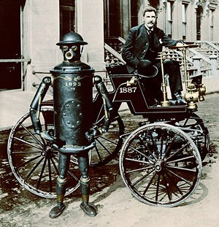

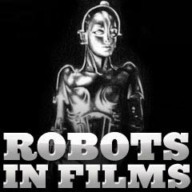

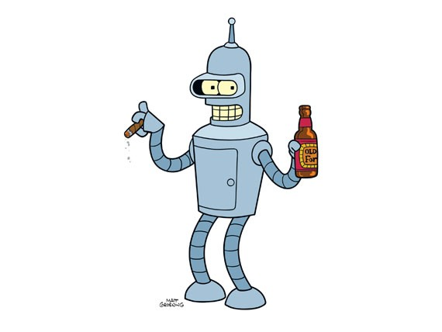

Histories of Animation

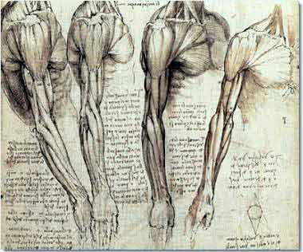

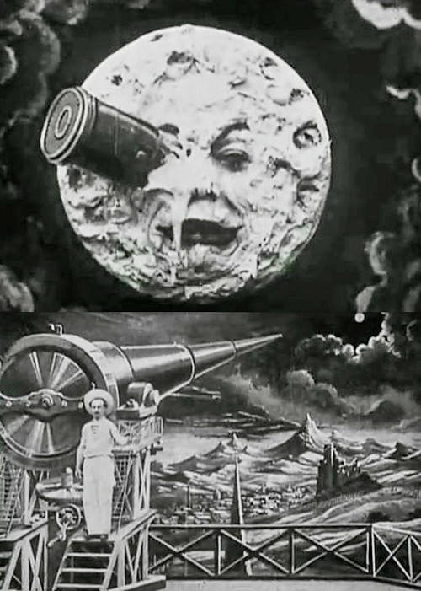

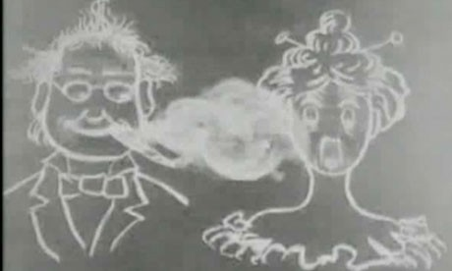





Histories of Animated Robots

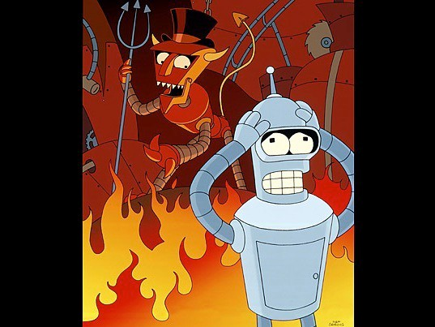

Histories of Photography

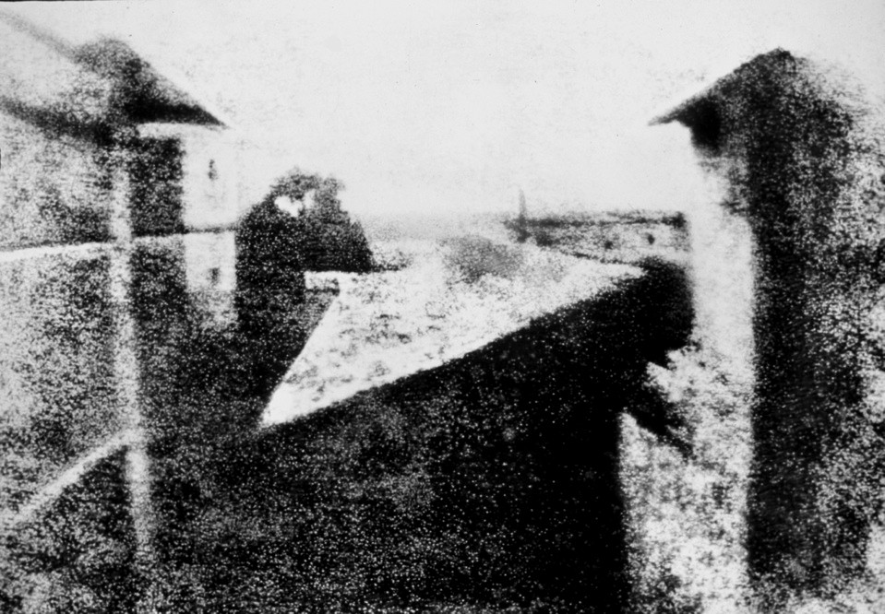

Histories of Brixton







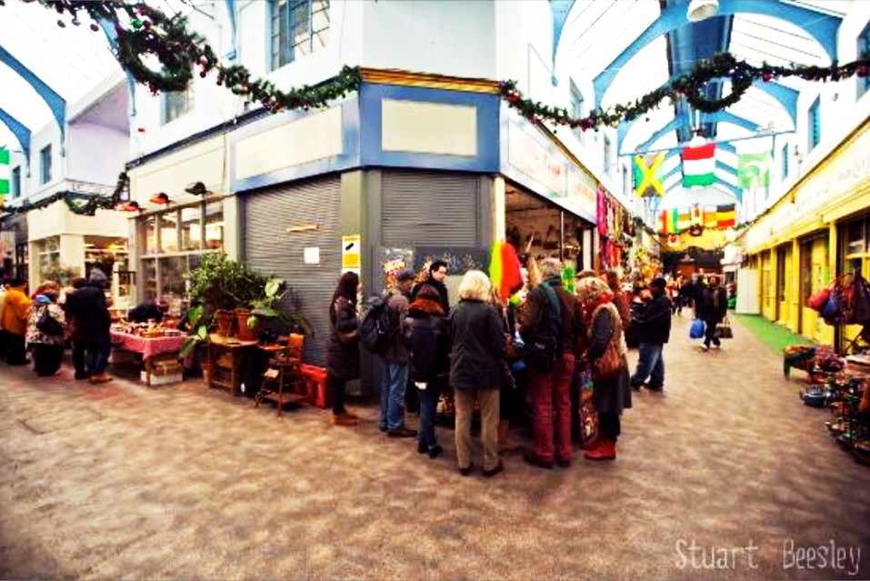



Histories of South London

"On the right side of the path leading from Peckham to Nunhead, appears this building, environed with wood. It has a singular appearance, and certainly was the eﬀect of a whim. Various tales are related of its founder; but the most feasible appears his desire of giving employment to a number of artificers during a severe dearth. It is related that he employed five hundred persons in this building, and adding to the grounds; which is by no means improbable, as, on entering the premises, a very extensive piece of water appears, embanked by the properties taken from its bosom. In the centre of it is an island, well cultivated; indeed, the whole ground is now (1796) so luxuriantly spread, that I much doubt if such another spot, within a considerable distance from the metropolis, can boast such a variety and significance. The whole is within a fence; and, time having assisted the maturity of the coppice, you are, to appearance, enjoying the eﬀects of a small lake in the centre of a wood. Motives the most laudable, as before observed, induced the founder of this sequestered spot to give bread to many half-starved and wretched families; and, to use the phrase of our immortal Shakespeare, 'It is like the dew from heaven, and doubly blesses.' If from appearance we are to judge of the phrase, it thrives indeed; and what was meant as assistance to a neighbouring poor, and stragglers, wretched and forlorn, is now, with all propriety, the

Paradise of Peckham."

Histories of London

Histories of Power

Histories of Abuses of Power

Histories of Oppression

Histories of The Oppressed

Histories of Oppressors

Histories of Science Fiction

Histories of Migration

Histories of Immigration

Histories of Nomadism

Histories of Colonialism

Histories of Anti-Colonialism

Histories of Riots

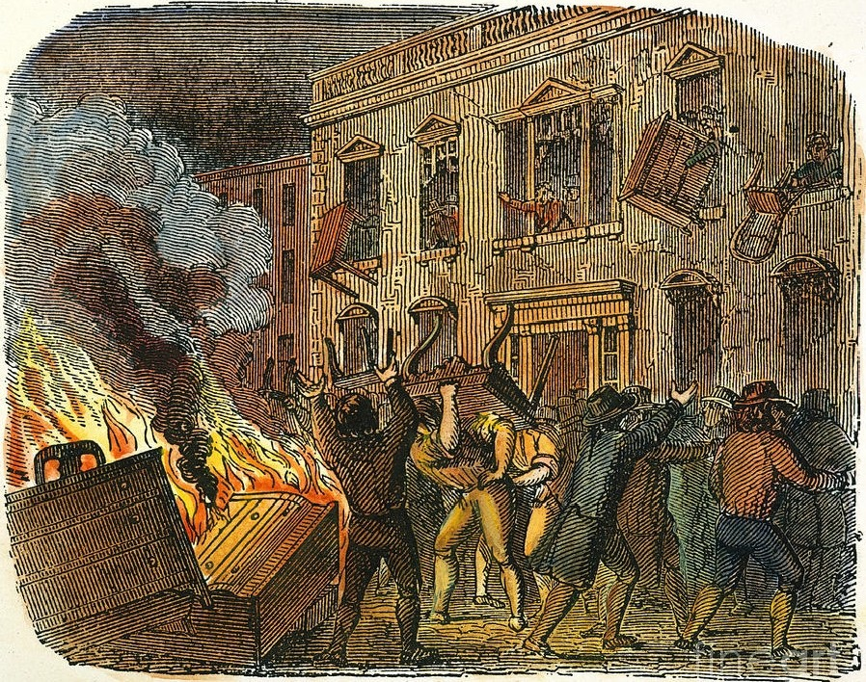

Attack on the. Governor's House.

Histories of The Brixton Riots

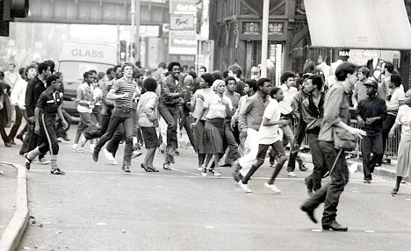

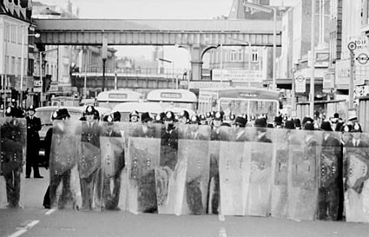

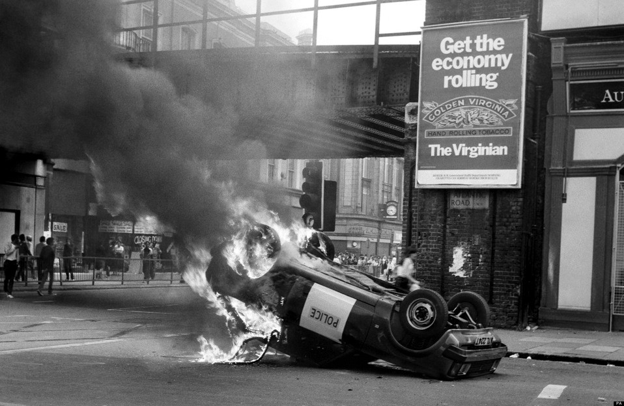

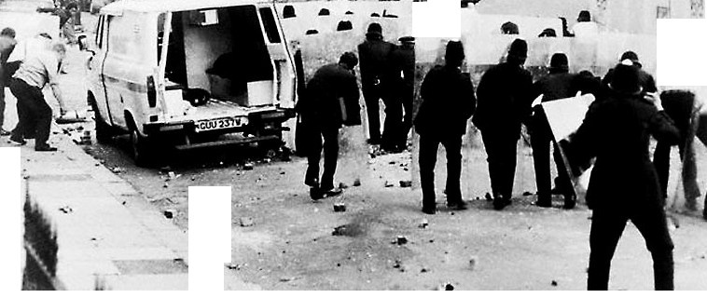, -
'

• ..... ..

' - .
.

-f
•

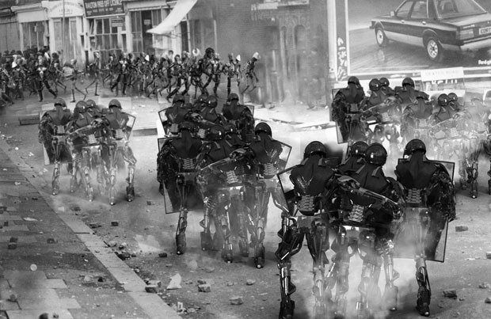

Histories of Racism

Histories of Film

Histories of Computers

Histories of Automatons

Histories of Post-colonialism

Histories of CGI

Histories of Movement

Histories of Time

French philosopher Henri Bergson's Matter and Memory (1896) has been cited as anticipating the development of film theory during the birth of cinema. Bergson commented on the need for new ways of thinking about movement, and coined the terms "the movement-image" and "the time-image".

Decades later, in Cinéma I and Cinema II (1983–1985), the philosopher Gilles Deleuze took Matter and Memory as the basis of his philosophy of film and revisited Bergson's concepts, combining them with the semiotics of Charles Sanders Peirce.

Histories of Histories

Histories of ?

(Activity)

(You are intrigued by some of the methods of analysis that
have been suggested to you.

Which ones would you choose and why?
Are then any others you could suggest might be useful that have not been mentioned?

Choose 3 examples of ways of looking at this film or your practice that might help you understand it more.

Send 5 minutes with a partner discussing this and then write your 3 examples down.)

Some methods of analysis?
Historical, Sociological, Psychological, Political,
Marxism, Frankfurt School, Critical Theory, Capitalism, Commodification, Psychoanalysis, Feminism, Gender studies,
Postcolonial Criticism
Semiotics, Aesthetics, Visual Rhetoric/Visual Literacy Technological, Apparatus theory Ethnographic, Anthropological
Literary theory, Linguistics, Discourse Analysis. Narratology, Hermeneutics Philosophical, Ethics, Aﬀect/Eﬀect
Formalist film theory, Genre studies, Iconic analysis, Auteur theory,
Phenomenology,
Quantitative Research, Data Collection and Analysis, Positivism, Empirical, Observation,
Interviews, Post-modernism,
Structuralism, Post-structuralism, Deconstructivism,
Action Research, Exploratory Practice,

Who is Kibwe Tavares?

Auteur theory

(Auteur Theory is the theory of filmmaking in which the
director is viewed as the major creative force in a motion picture.
Arising in France in the late 1940s, the auteur theory— as it was dubbed by the American film critic Andrew Sarris
—was an outgrowth of the cinematic theories of André Bazin and Alexandre Astruc.
A foundation stone of the French cinematic movement
known as the nouvelle vague, or New Wave, the theory of director-as-author was principally advanced in Bazin’s periodical Cahiers du cinéma (founded in 1951).
Two of its theoreticians—François Truﬀaut and Jean-
Luc Godard—later became major directors of the French New Wave.)

Posted by Kibwe X-Kalibre Tavares at 02:24

2 comments
Thursday, 31 March 2011

March Presentation

On Monday we had our penultimate crit, it was a good day the critics where tough but on point. Here are some of the images that I presented, some are images I reworked and added more depth to from earlier in the project. Others are adapted photographs of the riots from social photographer David Hoﬀman as well as some concept images that will help me design my final shot of the film.

The animation is coming on and will be complete "Hopefully" In 8 Short weeks! Yikes

http://kibwetavares.blogspot.co.uk/

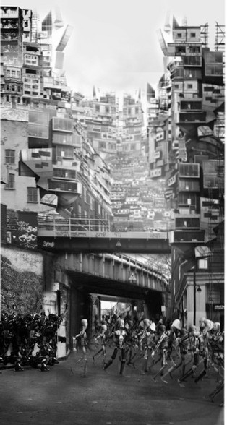

> • •
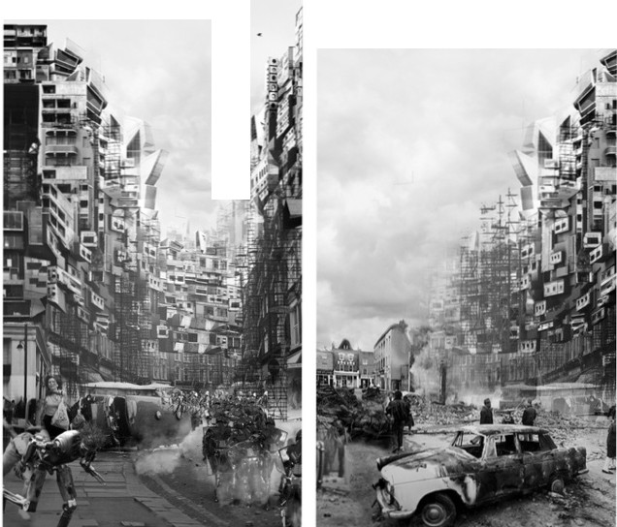... I." ..
•r r
• <

Kibwe Tavares is a director and actor, known for Jonah (2013), Robots of Brixton (2011) and Gamma (2012).

Sundance prize-winning director, Kibwe, was cited as one of Fast Company’s ‘100 Most Creative People in Business 2012’ and was recently awarded a prestigious TED fellowship. Recently he directed the Sundance film JONAH, a stunning combination of live-action shot on location in Zanzibar with beautiful visual eﬀects created at Factory Fifteen.

Kibwe created Robots of Brixton while pursuing a Masters degree in architecture, at The Bartlett School of Architecture. UCL

Kibwe Tavares picked up the Jury prize for animation direction in this year's Sundance Film Festival for Robots
of Brixton, which also won the RIBA Silver Medal.

Factory Fifteen won 2 architectural 3D awards including 'Best Architectural 3d Film' (Golden Age) and 'Best Architectural 3D Image' (Megalomania). Their artwork has also been seen in many of the world's leading Architecture, design and 3D books, magazines and blogs, including Stash Mag, 3D World, 3D Artist, Dezeen, Creative Web and
Evolo.

http://factoryfifteen.com/7931/about

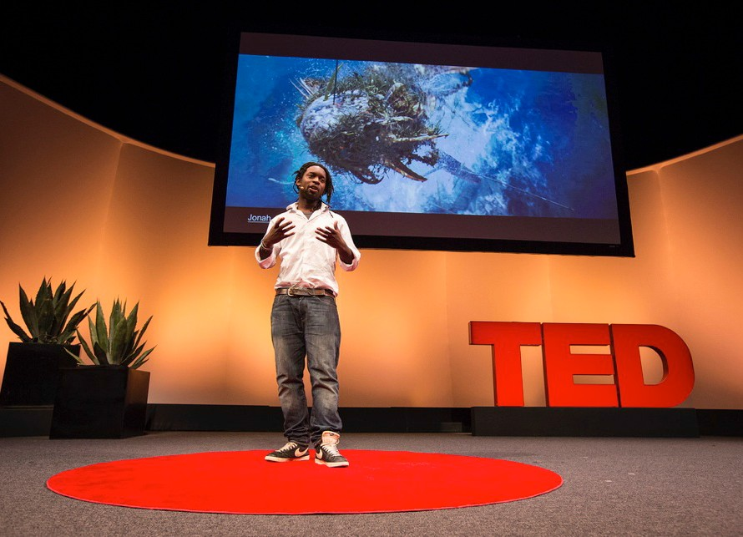



Some methods of analysis?

Historical, Sociological, Psychological, Political,
Marxism, Frankfurt School, Critical Theory, Capitalism, Commodification, Psychoanalysis, Feminism, Gender studies,
Postcolonial Criticism
Semiotics, Aesthetics, Visual Rhetoric/Visual Literacy Technological, Apparatus theory Ethnographic, Anthropological
Literary theory, Linguistics, Discourse Analysis. Narratology, Hermeneutics
Philosophical, Ethics, Aﬀect/Eﬀect
Formalist film theory, Genre studies, Iconic analysis, Auteur theory, Phenomenology,
Quantitative Research, Data Collection and Analysis, Positivism, Empirical, Observation,
Interviews, Post-modernism,
Structuralism, Post-structuralism, Deconstructivism,
Action Research, Exploratory Practice,

You ask your self:

Who is Karl Marx?

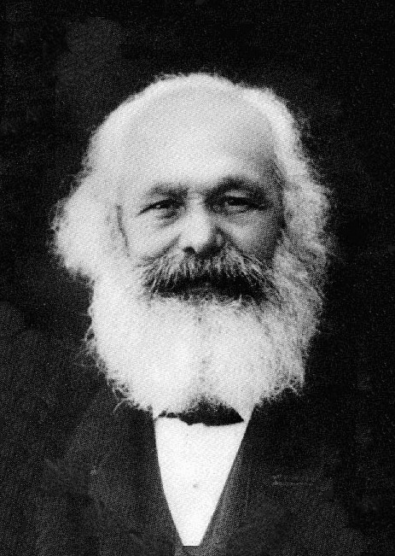

(“Mankind thus inevitably sets itself only such
tasks as it is able to solve, since closer examination will always show that the problem itself arises only when the material conditions for its solution are already present or at least in the course of formation!”

Karl Marx (1859) in the Preface of, A Contribution to the Critique of Political Economy.)

..........

“Research in Action”

“Research IS Action”

“I hear and I forget,
I see and I remember, I do and I understand.”

From: Edugraphology The Myths Of Design And The Design Of Myths By Victor Papanek 1975. (First published in Icographic no. 9 (Croydon, England: 1975).



